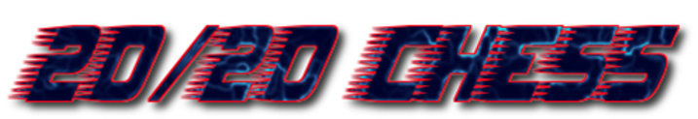

A National Rapid-Play Team Championship Open to All!
Kindly sponsored by Chess & Bridge

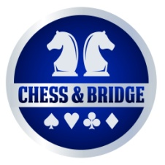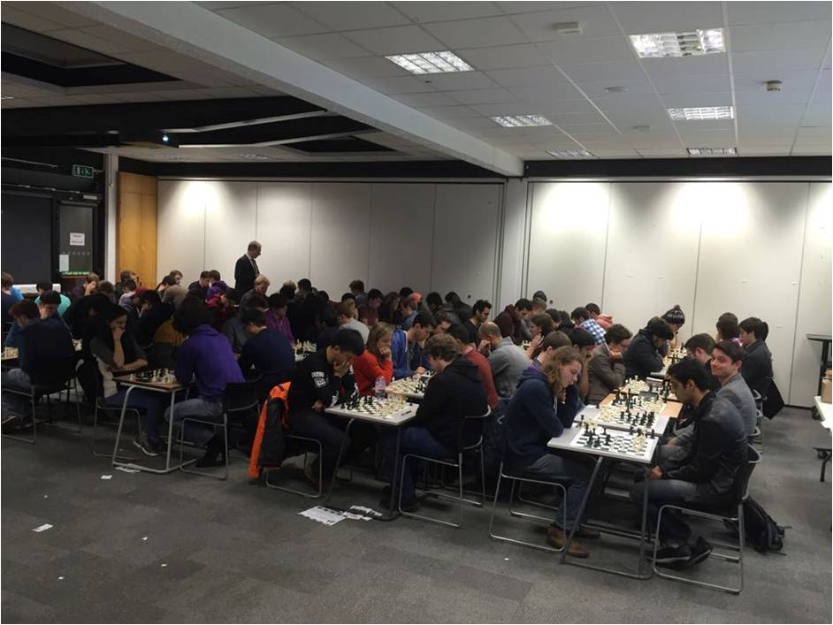

Events taking place across the country including:

Edinburgh: 22nd October

London: 29th October

Leeds: 12th November

York 21st January

Birmingham 28th January

February 4th February

Resulting in a Super-Final next summer to determine the best 20/20 Chess team of four in the UK with cash prizes trophies and medals up for grabs along the way!

Just £10 per person to participate, see www.2020chess.com for more details and email director@2020chess.com to enter now!

(Don’t have a team? Don’t worry, you can also sign up as an individual and be randomly allocated into a mixed Barbarians side on the day)
Recognised by the English Chess Federation 