**British Championship Qualifying Grand Prix – Rules 2017/18**

1. The British Championship Qualifying Grand Prix to all players qualifying for entry in accordance with the terms of the current version of the British Isles Co-Ordination Committee (BICC) Agreement. Only players who are eligible, or not qualified by other means will appear in the standings.

2. Qualifying tournaments will be those registered with FIDE for rating for the monthly periods August 2017 – July 2018 inclusive under the jurisdiction of the BICC. This will include all tournaments that are completed between 1st July, 2017 and 30th June, 2018. Tournaments included will be those are that are open all players with no rating or geographical restriction, be played at a standardplay time limit, and have a minimum of five and a maximum of eight rounds.

3. A player is deemed to have played in an event if they have played at least two games in that tournament. An event must have at least 10 players.

4. The top twelve places will gain points in the Grand Prix. Placing is based on all event competitors including those who are excluded from this Grand Prix. Tie breaks will be ignored for *placing scores*. Where a there is a tie for a place, points will be averaged for those involved in the tie.

5. The *event strength* will be determined by the average rating of the top ten players who played in the event and the average of all rated players.

6. The *placing scores* depend on the number of contestants are as follows:

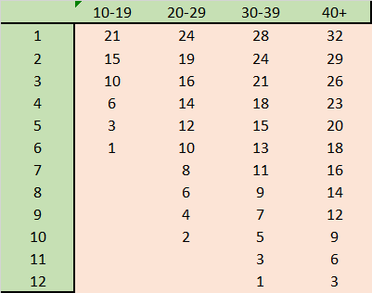

7. *Event strength* is zero for a player not entitled to points per the table in 6. The highest placed player has event strength points determined by adding one point for every full ten points the average rating of the highest ten contestants is more than 1900. Those with half maximum points are assumed to play the average rating and one point is added to every full ten points this average is more than 1900. Those entitled to points in between these limits get the interpolated points based on total of game results (on 1, ½,0 scale).

8. A player’s Grand Prix points are determined as: *placing score* + *event strength* points

9. A player who has qualified by another route will remain in the placings for each event they play in but will be removed from the Grand Prix table.

10. The final positions in the Grand Prix will be determined by the following ratio for all eligible players:

* 1. Determine the number of events the player has competed in.
  2. Calculate one quarter of that number rounded down
  3. Rank the GP points for all events
  4. Discard the worst scores for the number of events calculated in b
  5. Calculate the total points from the remaining events
  6. The divisor is the a-b with a minimum of 3.
  7. The ratio to determine qualifying places is e/f.