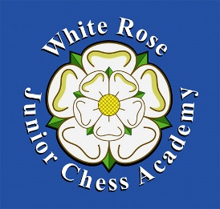
Yorkshire Junior One Day Rapidplay.
Date Saturday 13th January 2018 at 10.00am-4.00pm.
Wigginton Primary School,Wesstfield Lane Wigginton York YO32 2FZ
Tel;01904-552225
Ages- 6-18
Entry fee: £10.00 payable by cheque to White Rose Junior Chess Academy (see www.whiterosejuniorchessaccademy.org.uk).
Outline of the day:
1. Swiss System Rapid play in 3 sections - Open, Minor and Novices (NOT A KNOCKOUT EVENT) Various prizes will be awarded.
2. Good chess training will be available given by qualified coaches with DBS clearance.
Publicity photographs may be taken.
Refreshments will be provided.
The Aim of the day: to enjoy yourself, learn more about the exciting game of chess and make new friends.
--------------------------------------------------------------------------------------------------------------------------
Yorkshire Rapidplay entry form 13th January 2018
Name-------------------------------------------------------------.
Address-----------------------------------------------------------
School------------------- D O B------------------------------------
Email-------------------------------Emergency contact number--------------------------
Any special requirements?----------------------------------------------
Section preferred – Open, Minor, Novice?-----------------Months/years playing chess?-----------
Please send entry form and payment to Noel Stewart,30,Upper St Pauls Terrace, York North Yorkshire YO24 4BP Tel ;M 07572682101, Email;noel338@btinternet.com

