Tradewise Gibraltar Chess Festival 2018
Monday 22 January - Thursday 1 February 2018

Round 2 Report: Wednesday 24 January 2018 - by John Saunders (@JohnChess)

Super-GMs in Purgatory

The favourites had another tough day at the office in round two of the Tradewise Gibraltar Masters, played at the Caleta Hotel on 24 January 2018. Several distinguished heads rolled, while four-times winner Hikaru Nakamura had to slog away for more than seven hours to overcome Valentina Gunina's resistance.

Top board Maxime Vachier-Lagrave, hereafter abbreviated to the name by which he is universally known, MVL, was held to a draw by Swedish Erik Blomqvist. The elite players are finding it hard to get the better of improving players in the 2500-2550 category, such is the depth of strength in the Gibraltar field. Nakamura-Gunina exemplified this over the long distance. The US player strained every sinew to win in the middlegame but his Russian opponent defused all his tactics to reach an endgame where she had queen for two rooks and where the odds seemed to be on a draw. But, as we know, players in the 2750+ category don't understand the concept of a drawn position and just keep plugging away until something gives. It's not just Carlsen these days – he's inspired his leading rivals to do the same. Credit to Nakamura for supreme tenacity, and also to Gunina for putting up such fantastic resistance.

Boards three and four both featured giant-killings. David Navara seemed to be getting a significant kingside initiative against Das Debashis but overplayed his hand slightly after which he was slightly worse and finally just lost. Nikita Vitiugov, a former winner of the Masters, got nothing from a Ruy Lopez opening and tried some sacrificial tactics perhaps designed to secure a perpetual. But the young Indian GM Shardul Gagare capitalised on the extra material and gradually shut the Russian super-GM's queen out of the game to win.

The third 2700+ player to be defeated was Wang Hao of China. He lost to former women's world champion Antoaneta Stefanova, who always brings her best game to Gibraltar. The game started life as a d4 d5 opening before mutating into a sort of French Defence with pawns becoming locked across the entire. Perhaps Wang Hao feared that would lead too easily to a draw so he imbalanced the position by sacrificing a pawn to control the light squares on the queenside. But this proved disastrous as the Bulgarian player turned her attention to the kingside and Black's queenside pieces were left looking out of play. White secured extra material and that was that.

Such is the enormous strength of this tournament that super-GMs who, shall we say, perform at a sub-optimal level by their stratospheric standards, can find themselves playing on quite low boards. The Caleta Hotel does not have a room sufficiently large to accommodate all the boards of the tournament, so games are spread across the main hall, on the first floor, and what is known in the hotel as Nuno's Restaurant which is actually two (or is it three?) floors lower down, where boards 70 and beyond are located. This is not actually a subterranean area, I hasten to add, as it enjoys pleasant views over the sea, but in chess terms it has been unkindly compared (usually by me) to hell. The red wallpaper in the lower area makes the demonic metaphor seem more apt.

Very few super-GMs find themselves banished to the fiery pit, but there is a middle area which is a side room off the main hall where boards 50 to 70 are played. Unfortunately there are no live boards in this area, which means that we cannot broadcast games in real time from there. Instead the players must play on what Nigel Short has dubbed 'dead boards' (i.e. not live, therefore dead – Nigel is nothing if not a consummate logician). He and I debated what this area should be named. I can't recall his exact words but I believe he favoured something along the lines of 'rabbits corner'. I was toying with 'the dead zone' after the area on Everest where ancient corpses strewn across the landscape, preserved in the deep-freeze conditions, remind living mountaineers of the perils of their hobby. Perhaps that is too unwholesome for common parlance. An alternative might be 'chess purgatory' which more aptly describes the area where underperforming super-GMs can purge their chessboard sins before returning to the blessed light of boards 1-50.

Anyway, it was noticeable that two of the super-GMs in purgatory in round two didn't hang around for long. Aronian and Short turned their back on Satan in pretty quick time. A third one, Pentala Harikrishna, however, could only draw against Anita Gara, who is proving a thorn in the flesh of the super-GMs, having drawn with Levon Aronian in round one. I've noticed that Anita is lined up to play Vitiugov today. Just think about that for a moment – pairings against players rated 2797, 2745 and 2732 in the first three rounds. Has anyone, ever, had such tough pairings to start an open tournament?

At the end of the round there were still 34 players on the maximum score, including five of the women competitors. One particularly eye-catching game was Kazakhstan IM Dinara Saduakkasova's win against Tamas Banusz. The Kazakh player was conceding around 170 rating points to her opponent but she comprehensively outplayed her GM opponent, finishing off with an unstoppable advance by Simon Williams's favourite pawn.

Tradewise Gibraltar Masters, Round 2, 24.01.2018
D.Saduakassova (2470) - T.Banusz
1.d4 d5 2.c4 e6 3.Nc3 c6 4.e3 f5 5.Bd3 Bd6 6.Nf3 Nf6 7.0-0 0-0 8.b3 Ne4 9.Ne2 Qe7 Quite a number of previous games have proceeded 9...Nd7 10.Bb2 Qf6 with results not favouring either side particularly, but noticeably few draws. 10.Bb2 b6 11.Ne5 Bb7 12.Rc1 c5 13.Nf4 Nf6 14.Qe2 a5 15.cxd5 Bxe5 16.dxe5 Nxd5 17.Rfd1 Nc6 18.Nh5!?
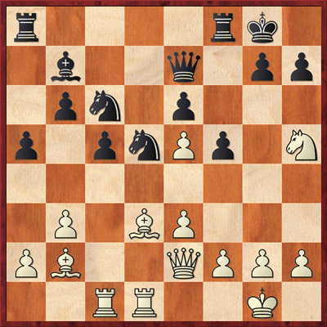
Diagram left

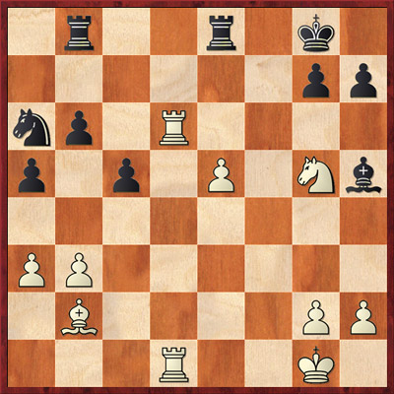
A strange move but perhaps an inspired one. It certainly has a bearing on the outcome of the game. The knight is not easily ousted from here since 18...g6 would allow 19.Nf6+. 18...Ncb4 19.Bb1 Qg5 20.f4 Qg6?! It is understandable that Black should want to exploit pressure against g2 but he may have misjudged the position after the following exchanges. 21.a3 Na6 22.e4! Good judgement. White emerges from the white square battle with an advantage. 22...fxe4 23.Bxe4 Nxf4 24.Nxf4 Qxe4 25.Qxe4 Bxe4 26.Nxe6 Rfe8 27.Rd6 White now enjoys a significant advantage, based on the well-supported passed e-pawn, plus having much the better knight. 27...Rab8 28.Ng5 Bg6 29.Rcd1 Bh5?

Diagram right

After this Black is suddenly lost, though it requires bold and incisive play to deliver the win, which White achieves admirably. Instead Black should play 29...Nc7 after which the position may be equal: 30.Rd7 Ne6 31.Nxe6 Rxe6 32.R1d6 Bf5 looks defensible. 30.Rd7!! Beautifully calculated. White gives up a rook for a mating attack. 30...Bxd1 The best the computer can come up with is 30...Rbc8 31.e6 Rc7 32.R1d5 but White is still winning, with powerful threats of Bxg7 and Be5. 31.e6! Bc2 32.Rxg7+ Kf8 33.Rf7+ Kg8 34.Rg7+ White gains some time on the clock. 34...Kf8 35.Rf7+ Kg8 36.e7! Now the threat is 37.Rg7+ Kh8 38.Rg6 mate, so Black has to give back the rook. 36...Rxe7 37.Rxe7 Bxb3 Black has made the best of it, even emerging a pawn up, but he has not shaken off the attentions of the rook, bishop and knight. 38.Nxh7 White now threatens 39.Rg7+ followed by 40.Ng5 with a forced mate so the bishop is forced back to block checks on g7. 38...Bf7 39.Ng5 Rf8 Black has somehow shored up his king's position but all that's left to him are pointless moves on the queenside. So how does White proceed? diagram

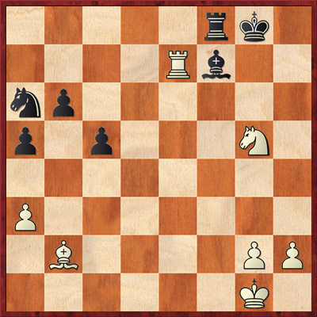
40.h4! Cometh the hour, cometh Harry the h-pawn. A moment to gladden the GingerGM's heart as our commentator's favourite pawn launches down the board to administer the coup de grâce. 40...Nb8 41.h5 Nc6 41...Bxh5 42.Rg7+ Kh8 43.Rh7+ Kg8 44.Rh8 mate. 42.h6! 1-0 A second rook sacrifice. It just proves that, on a good day and with a following wind, Harry the h-pawn is worth two rooks. Disappointingly, Black now resigned and denied Harry the ultimate satisfaction of delivering mate.

A selection of photos of round two can be downloaded from the JohnChess Flickr account or access the media section of the official website for a further selection of photos by Sophie Triay, John Saunders and Patricia Claros.

Video footage and interviews from today's round are available to embed from the Tradewise Gibraltar YouTube Channel.

Report Ends

Official website: www.gibchess.com
YouTube Channel

John Saunders
Press Reporter, Tradewise Gibraltar Chess Festival
Official website: www.gibchess.com - Twitter @GibraltarChess, official hashtag #GibChess
Personal Twitter Account @johnchess

