Monday 22 January - Thursday 1 February 2018

Round 4 Report: Friday 26 January 2018 - by John Saunders (@JohnChess)

Nakamura Stands Alone

After the third day's play at the Caleta Hotel just one player remains on 4/4: predictably, Hikaru Nakamura. The four-times Gibraltar Masters winner is now half a point clear of ten players on 3½: Jan-Krzysztof Duda (Poland), Benjamin Gledura (Hungary), David Howell (England), Maxime Vachier-Lagrave (France), Mikhail Antipov (Russia), Emil Sutovsky (Israel), Ivan Saric (Croatia), Rasmus Svane (Germany), Jules Moussard (France) and Andrey Esipenko (Russia). The leading women, on 3 points, are Pia Cramling (Sweden), Dina Saduakassova (Kazakhstan), Nino Batsiashvili (Georgia), Anna Muzychuk (Ukraine), Valentina Gunina (Russia), Ju Wenjun (China), Szidonia Lazarne Vajda (Hungary), Irine Kharisma Sukandar (Indonesia) and Lei Tingjie (China).

Everyone in Gibraltar is remarking on how relaxed Nakamura seems. His confident mood is not unlike that of Magnus Carlsen in the Isle of Man last autumn, when the Norwegian was able to cope better with the rough and tumble of an open event than some of his rivals who were more used to the rhythms of round-robin play. Nakamura probably just seems more relaxed because he is familiar with the venue – it's his eighth visit – and he is comfortable with the format. Here's his fourth round victory over Nils Grandelius.

Tradewise Gibraltar Masters, Round 4, 26.01.2018
H.Nakamura (2781) - N.Grandelius (2647)
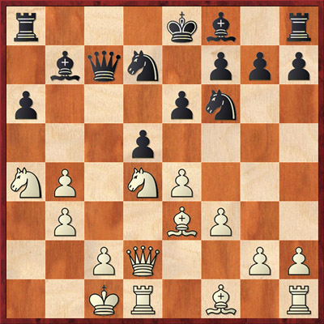
1.e4 c5 2.Nf3 d6 3.d4 cxd4 4.Nxd4 Nf6 5.Nc3 a6 6.Be3 e6 7.f3 b5 8.Qd2 b4 9.Na4 Nbd7 10.0-0-0 Qa5 11.b3 Bb7 12.a3 White wins a pawn but it's not a significant gain in the long term. Both players are still in their book. 12...Qc7 13.axb4 d5 (diagram)

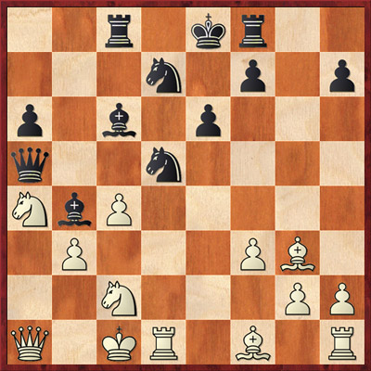
14.Bf2 Not completely unprecedented but this may have surprised Grandelius. 14.b5 is the most frequently seen move here, while Grandelius himself played 14.c4 a decade ago and lost. 14.exd5?! is frowned upon. After 14...Nxd5 the b4 pawn will drop off and Black will have a considerable queenside edge. So it is best to keep the b4–pawn and jettison the e4 one. 14...Bd6 Black decides not to regain the pawn but make it into a sacrifice. 14...dxe4 15.Bg3 Qc8 16.Bc4 was seen in a game between Christopher Yoo (playing in Gibraltar) against Preotu in the Calgary Open last August, which Yoo (playing White) won. 15.exd5 Nxd5 16.Bg3 Indirectly defending the b4–pawn. This was one of the points behind White's Bf2 move. 16...Rc8 16...Bxb4?? runs into 17.Qxb4! and White wins. 17.c4 17.Bc4 is also possible. 17...Bxb4 18.Qg5 If White had lost this game, we'd have been flagging up his foolhardiness in exposing his king to the full brunt of Black's queenside pieces, but White has calculated carefully. After the game Nakamura pointed out how long Black had taken to come up with his Bd6/Rc8. Time is an factor in White's advantage. 18...Qa5 19.Qxg7 Rf8 20.Nc2! Bc6 Doubtless Black would have liked to press on with something like 20...Nc3 but it doesn't work: 21.Nxb4 Nxd1 22.Nc2 and White will gain two minor pieces for a rook. 21.Qa1! (diagram)

21...Nc5 The best engine suggestion is 21...N7b6 22.Nxb6 Qxa1+ 23.Nxa1 Nxb6 but Black has no compensation for his pawn. 22.Nxc5 Qxa1+ 23.Nxa1 Ba3+ 24.Kd2 Bb4+ 25.Kd3 Nc3 26.Nxa6! To the non-super-GM eye it looks as if White's could get into trouble after this but White has calculated concrete lines and knows he is safe. 26...Rd8+ 27.Kc2 Rxd1 28.Nxb4 Rxa1 29.Kxc3 Kd7 30.Nc2 Rb1 31.Ne1 Ra8 32.Bd3 Rc1+ 33.Kd2 Raa1 34.Be5 Rd1+ 35.Ke2 Rac1 36.Bb2 1-0

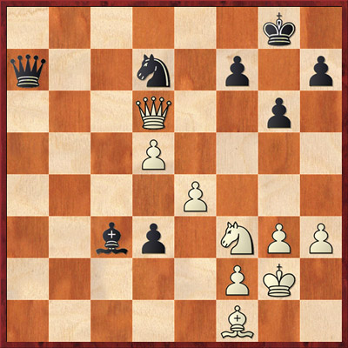
There were quite a few draws amongst the leading pairings but a notable exception was Vachier-Lagrave versus Nino Batsiashvili where the number two imposed himself to garner a win. Nino impressed in last autumn's Isle of Man International and she's done well too, perhaps showing that she relishes playing against the world elite, but MVL was a little too strong for her.

Emil Sutovsky moved up to the second score group on 3½ with a win against Mariya Muzychuk, as did Ivan Saric, who beat Indian GM Dhopade Swapnil. But Saric was actually a bit lucky as his opponent missed a trick which would have turned the tables near the end of the game.

Tradewise Gibraltar Masters, Round 4, 26.01.2018
I.Saric (2664) - D.Swapnil (2533)

35...d2?? Missing the gorgeous 35...Be1!! which is what I call a Sherlock Holmes move - very difficult to see yourself but immediately obvious once it's pointed out to you. Since there is no other way to defend f2, Black has to play 36.Nxe1 when 36...d2 and the pawn promotes. 36.Be2 Now Black is struggling. 36...Qa4 37.Qc7! Qxe4 Now, if 37...Ba5 38.Qa7! ties Black in knots, while; after 37...Bb4, simply 38.e5! and White has too many threats. 38.Qxd7 Qxe2 39.Qc8+ 1-0 White will capture on c3 with check and then snaffle the d2–pawn.

Prodigy-watch: the two Indian stars are finding the going tough in the world's top open tournament. Praggnanandhaa drew with Black against Felix Blohberger, an Austrian FM who is himself only 15 and a useful prospect. Meanwhile Nihal Sarin lost with White against Szidonia Lasarne Vajda, who memorably held Vishy Anand to a draw in the first round of this tournament two years ago. Evidently Szidonia relishes playing Indian superstars, present and future.

A selection of photos of round four can be downloaded from the Flickr collections of John Saunders or Sophie Triay.

Video footage and interviews from today's round are available to view and/or embed from the Tradewise Gibraltar YouTube Channel.

Report Ends

Official website: www.gibchess.com
YouTube Channel

John Saunders
Press Reporter, Tradewise Gibraltar Chess Festival
Official website: www.gibchess.com - Twitter @GibraltarChess, official hashtag #GibChess
Personal Twitter Account @johnchess

