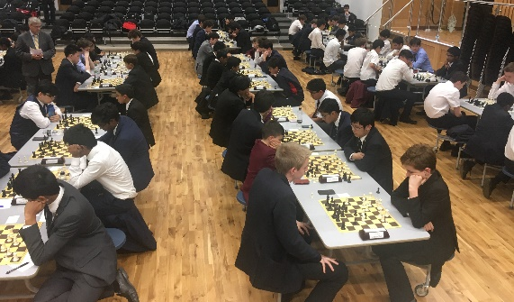 | ECF Secondary School Chess News  November 2017  Neill Cooper,  ECF National Secondary  School Co-ordinator  manager.schools@englishchess.org.uk | 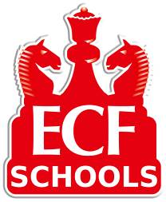
Click on any of the underlined hyperlinks for more details.

ECF National Schools Chess Championships 2017/18
We are very grateful to Winchester College (U19 Open) and St Catherine’s School, Bramley (U19 Girls’) for their continued sponsorship of these tournaments.

U19 Open
So far 101 schools have entered a total of 157 teams in this tournament. There are now limited opportunities for more teams to be entered between now and the end of November. Click on the title for more information and a link to the entry form or email the Controller, John Swain. Results of qualifying events are now being shown. Details of the spring term Regional stage will be circulated to qualifiers in early December.
U19 Girls
Teams in this event are of 3 female players. Entry is open to Mixed schools as well as Girls only schools. There are one day semi-finals in the North and South in January, with leading teams progressing to the finals in the Easter Holidays. Already we have 20 teams entered but there is plenty of space for more. Entry form Controller: Andrew Martin
ECF School Blitz
The Second ECF National Schools Individual and Team Blitz will take place at The King's School Grantham on Saturday 17 March 2018 from 11.00 am - 4.00 pm. Entry is free to all secondary schools and sixth form colleges in the U.K.
Blitz is a fast and fun form of chess where each player has just three minutes initially and gains two seconds per move. There is an individual event in the morning and a team event in the afternoon. For more details see the website, where you can also find the entry form.

ECF Team Chess Challenge and ECF Junior Team Chess Challenge
Local events for teams of 4 players where the winning team qualifies for National Finals in April 2018. Some Regional finals have already been planned, more will be announced during the Autumn Term. TCC is for any age, JTCC for year 8 and below. We would welcome more venues for regional events. Schools can now enter more than two teams if the host school allows. If you are willing to consider hosting an event please email me and I can provide more information.

Dates of other Secondary School and related chess team events
Saturday 25th November 2017 11am to 5pm
Birmingham Junior Chess League U18 Rapidplay Tournament for teams of 6 players. This is also an ECF U19 National Schools Chess Championship qualifying event.
Contact: Dominic Tuohey: dlt@kes.org.uk

Sunday 3rd December 2017 2pm to 5pm
ECF U19 National Schools Chess Championship Qualifying Repechage at University College London. More details Neill Cooper, manager.schools@englishchess.org.uk

Sunday 25th February 2018, ECF U18 County Championships 11am - 4 pm
Your players might like to play for their county, “County chess player” looks good on UCAS forms! The ECF U18 county championships will be held on Sunday 25th February at The King’s School, Grantham. Open and Minor (under 130 grade) sections. Do check that your county is planning to enter a team and suggest to your pupils that they could be in one of the teams.
Saturday 17 March 2018 11am - 4pm
ECF National Schools Individual and Team Blitz at The King's School, Grantham

Sunday 29th April 2018 11am to 5.30pm
ECF U19 National School Chess Championships Final Repechage at Eton College

Tuesday 3rd and Wednesday 4th July 2018
ECF U19 National School Chess Championships National Final at Uppingham School

Sunday 16th September 2018 11am to 5.30pm
ECF School Rapidplay and U19 National School Chess Championships Qualifying event at Eton College.

For up to date information visit http://englishchess.org.uk/NSCC/

