Best KEGS Round Badge Black with White Background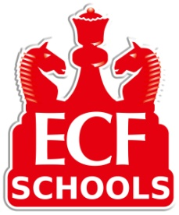**English Chess Federation**

**National Schools**

**ECF Team Chess Challenge**

**ECF Junior Team Chess Challenge**

**King Edward VI Grammar School,**

**Broomfield Road,**

**Chelmsford, CM1 3SX.**

**Sunday November 25th 11am**

**KEGS are pleased to invite your school to take part in one of two secondary school chess competitions on Sunday 25th November. Schools can enter both competitions if they wish.**

**Each competition is for teams of 4 and each team will play every round. There will be 4 rounds with games lasting up to 20 minutes. Chess clocks will be used but the games are ungraded.**

**Each team can be made up of a squad of up to 6 players with players free to rotate each round.**

**The Junior Team Chess Challenge is open to students in Year 6 to 8 with at least 3 players in Year 7 or 8. Teams must consist of students from the same school.**

**The Team Chess Challenge is open to students from Year 6 to 13 with at least 3 players in Year 7 or above. Teams must consist of students from the same school.**

**The competitions are ideal for students with little or no experience of competitive chess. Priority will be given to Essex schools if entry demand is high.**

**The competition winners will progress to a National Final.**

**There is ample parking at the school. Please bring lunch with you (drinks will be provided).**

**Registration is at 11am with the first round starting at 11.30am.**

**The entry fee (to cover costs) is £10 per school. Schools can enter a second team in either competition if space permits.**

**Entry by email and queries to both Tim Worrall (TiC of chess at KEGS) at** tworrall@kegs.org.uk **and Robin Slade at** [chelmsfordjuniorchess@gmail.com](mailto:chelmsfordjuniorchess@gmail.com)**. Please specify the competition and number of teams you wish to enter.**