ENGLISH CHESS FEDERATION NATIONAL CHESS CLUB CHAMPIONSHIPS 2009/10

MAJOR RESULT SHEET
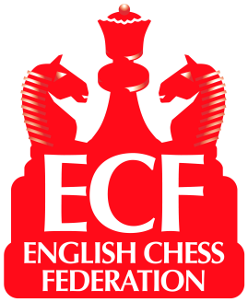

Result from …Hastings & St Leonards Chess Club Venue Hastings.. Date .10th April 2011
.
Home Team… Hastings & St Leonards Away Team…Snodland
Brd | Code * | Grade | Player | Result | Player | Code * | Grade
1 | 105672E | 192 | R J Almond | ½-½ | B M Spink (W) | 123107J | 191
2 | 110228L | 181 | R V Elliston (W) | 1-0 | Z Koncki | 27754F | 170E
3 | 222273F | 173 | R Norinkeviciute | 1-0 | T Wickman (W) | 264483G | 142
4 | 253474F | 164 | R P B Brooks (W) | 1-0 | D Lettington | 150118F | 132
5 | 277920B | 156 | A Chung | 1-0 | T Jefferies (W) | 113570D | 117
4½- ½
Average Grade :–
Average Grade :–
* See ECF Grading List for Code
150.4
173.2

TOTAL
Please indicate with “(W)” after their names players who had the white pieces
Results must be sent by both teams to the Controller to arrive within three days of the match.
Controller: Julie Johnson 105 Central Ave Syston Leics LE7 2EG
Email: juliedjohnson@yahoo.com
I declare the above results to be correct and that all players in my team were both bona fide members of the club and eligible under the competition rules and that estimated grades are as accurate as possible.

R J Almond
Home match captain’s signature

Away match captain’s signature
If the grade is not from the ECF National List, the captain must explain overleaf the List from which it is taken or enter the ‘Grade’ allocated by the Controller

