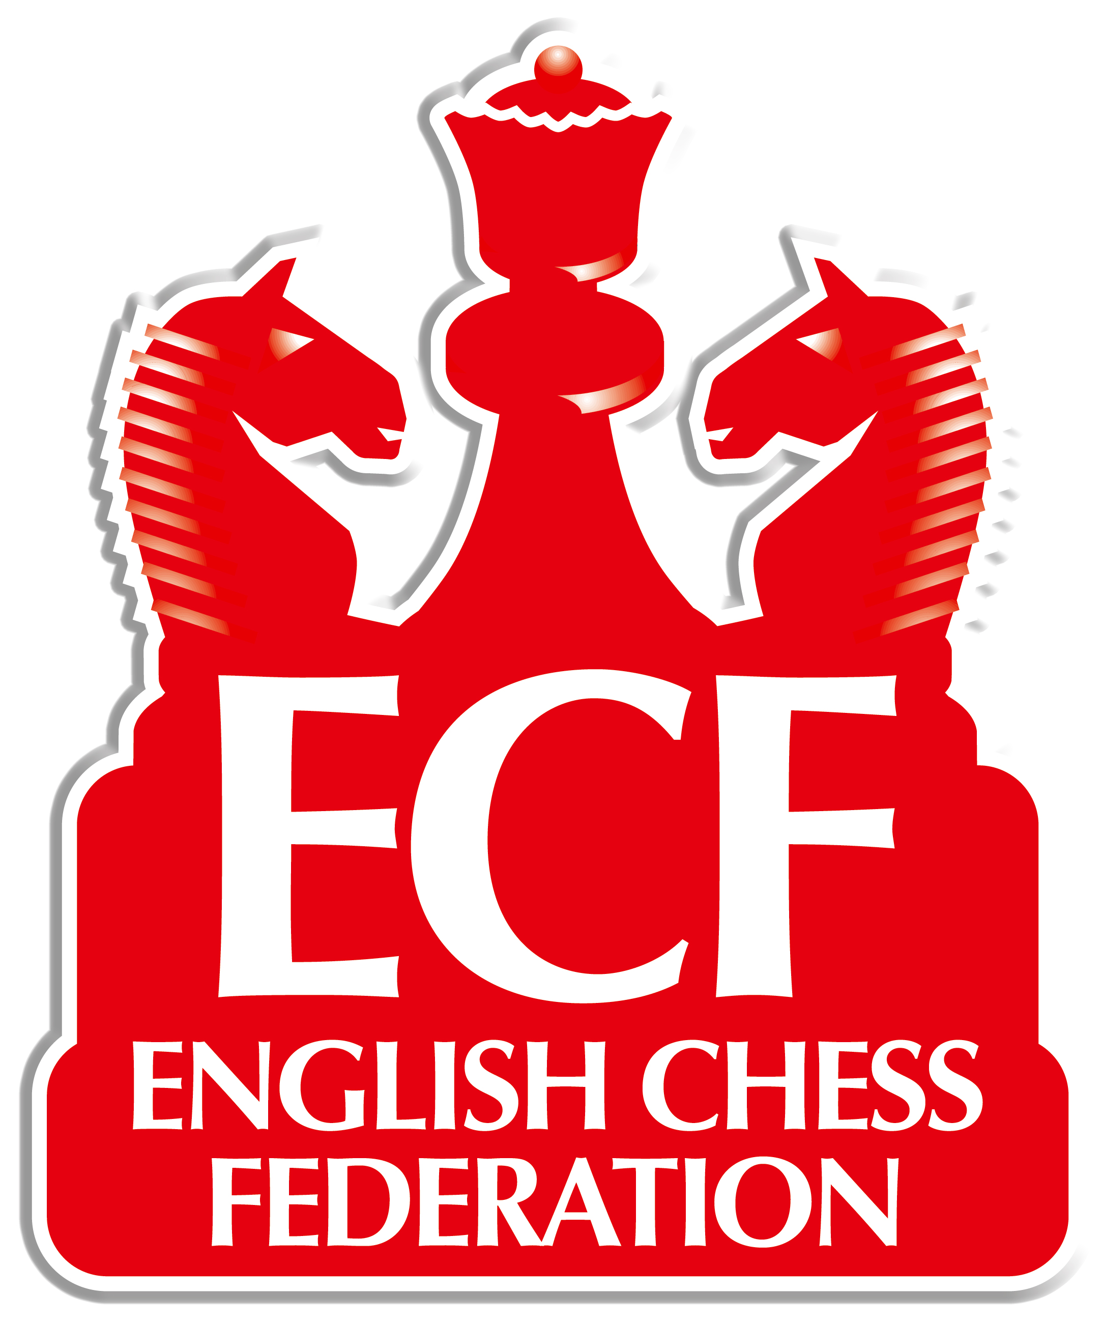
The English Chess Federation

Advice on running a Simultaneous Display

Decide on the type of display – open to all-comers, solely for juniors or a particular club? This will affect the choice of venue; if you want to attract interested members of the public, somewhere like a shopping mall can work well. Note that many locations will often give a venue free for some good publicity. Check that the proposed date does not clash with a local chess event or major occasion such as the FA Cup final.

If you need a player, contact the English Chess Federation Office.

Organise tables, chairs and chess sets; the first two are normally provided by the venue, the latter from a chess club.

Decide how to raise money. Will players pay a fee or might a local sponsor cover costs? You may decide to raise funds for a charity – spnsorship for a certain amount per move generally works well for juniors, while adults often prefer to pay a board fee.

Publicise the event through local papers, chess columns and magazines, radio, Teletext, clubs and schools, depending on the type of audience you wish to reach.

Try to get local firms or games shops, for example, to provide prizes for wins and draws.

On the day you will need assistance during the display; for example organising the players, providing refreshments, explaining to passers-by what is going on and generally being in charge.

After the event, report the results of the event to the providers of publicity and keep press cuttings and other media exposure – this will ease the task of finding a sponsor for the next event. Please send details of the event to the ECF office.

