ENGLISH CHESS FEDERATION NATIONAL CHESS CLUB CHAMPIONSHIPS 2010/11

RESULT SHEET FOR FINAL OF MAJOR PLATE
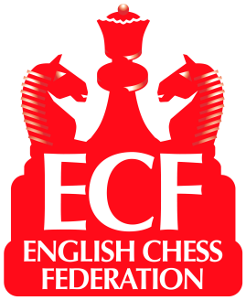

Result from Venue: GOLDEN LANE, LONDON Date: 10th July 2011
.
Home Team: FARNHAM Away Team: ATHENAEUM
Brd | Code * | Grade | Player | Result | Player | Code * | Grade
1 | 110949C | 199 | Clive Frostick | ½ - ½ | Daniel Farkas | 277816G | 194
2 | 188291A | 198 | Ian Sharpe | ½ - ½ | Charles McAleenan | 259304L | 178
3 | 158308G | 196 | Peter Hasson | ½ - ½ | Kevin Millward | 115576D | 168
4 | 109437D | 141 | Tim Davis | 1 - 0 | Jonathan Kay | 156230H | 159
5 | 261587D | 132 | Christian Montanari | 0 - 1 | Geoff Hermes | 243892G | 156
2½ - 2½
Average Grade :–
Average Grade :–
* See ECF Grading List for Code
171
173

Farnham win on Board Count

Please indicate with “(W)” after their names players who had the white pieces
I declare the above results to be correct and that all players in my team were both bona fide members of the club and eligible under the competition rules and that estimated grades are as accurate as possible.

Home match captain’s signature

Away match captain’s signature
If the grade is not from the ECF National List, the captain must explain overleaf the List from which it is taken or enter the ‘Grade’ allocated by the Controller

