ENGLISH CHESS FEDERATION NATIONAL CHESS CLUB CHAMPIONSHIPS 2010/11

RESULT SHEET FOR OPEN CHAMPIONSHIP
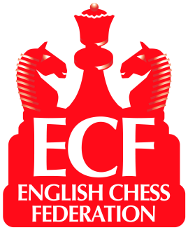

Result from Venue: GOLDEN LANE, LONDON Date: 10th July 2011
.
Home Team: WOOD GREEN Away Team: MUSHROOMS
Brd | Code * | Grade | Player | Result | Player | Code * | Grade
1 | 129715G | 237 | Nick Pert (W) | 1 - 0 | Ian Snape | 220905G | 204
2 | 115262C | 233 | Neil McDonald | 1 - 0 | Chris Briscoe | 107290A | 205
3 | 110255C | 229 | John Emms | 1 - 0 | Ron Harris | 112184E | 185
4 | 121112C | 230 | Chris Ward | 0 - 1 | Rory O’Kelly | 116391H | 181
5 | 110933K | 199 | Jonathan Friedland | 0 - 1 | Bill Linton | 114458D | 181
6 | 153490H | 200 | Desmond Tan | 1 - 0 | David Wilson | 267599H | 164
4 - 2
Average Grade :–
Average Grade :–
* See ECF Grading List for Code
187
221

Please indicate with “(W)” after their names players who had the white pieces
I declare the above results to be correct and that all players in my team were both bona fide members of the club and eligible under the competition rules and that estimated grades are as accurate as possible.

Home match captain’s signature

Away match captain’s signature
If the grade is not from the ECF National List, the captain must explain overleaf the List from which it is taken or enter the ‘Grade’ allocated by the Controller

