# 2017.png

# Tradewise Gibraltar Chess Festival 2017

**Monday 23 January - Thursday 2 February 2017**

***Round 9 Report: Wednesday 1 February 2017 - by John Saunders (@JohnChess)***

**David Slays Goliath**

The penultimate round of the Tradewise Gibraltar Masters finally saw a single player emerge from the field to take the lead, and that player is 21-year-old Spanish GM David Antón Guijarro, ranked 24th in the field in Gibraltar. He played a forceful positional game with Black to overcome Veselin Topalov, who seemed to be completely out of sorts, surprising us all with a premature resignation. Other games between the leaders were drawn, while five players in the 6 point score group won. This means that, with only one round left, David Antón Guijarro leads on 7½, with Hikaru Nakamura (USA), Maxime Vachier-Lagrave (France), Michael Adams (England), Yu Yangyi (China), Ju Wenjun (China), Ivan Cheparinov (Bulgaria), Boris Gelfand (Israel) and Romain Edouard (France) on 7 points. As regards the women's top prize of £15,000, Ju Wenjun seems to have this wrapped up already as she has a one-point lead over the women's field, plus a considerably superior tournament performance rating to her rivals.

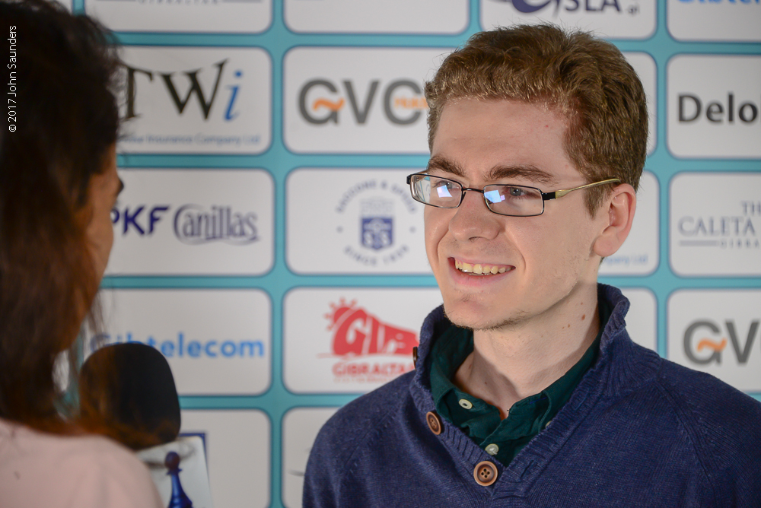

*David Antón Guijarro (Spain) is the surprise leader going into the final round.*

The writing was on the wall for the top board game between Maxime Vachier-Lagrave and Yu Yangyi when Black defended with a Petroff, which preceded the Berlin as the favourite method for Black to dig in for a draw when faced with 1.e4. It was all too effective here and not much happened on this board. Nakamura-Caruana showed the same super-GM approach to defending 1.d4, with Caruana going in for the Queen's Gambit Accepted and an unusually cagey Nakamura allowing an early queen exchange.

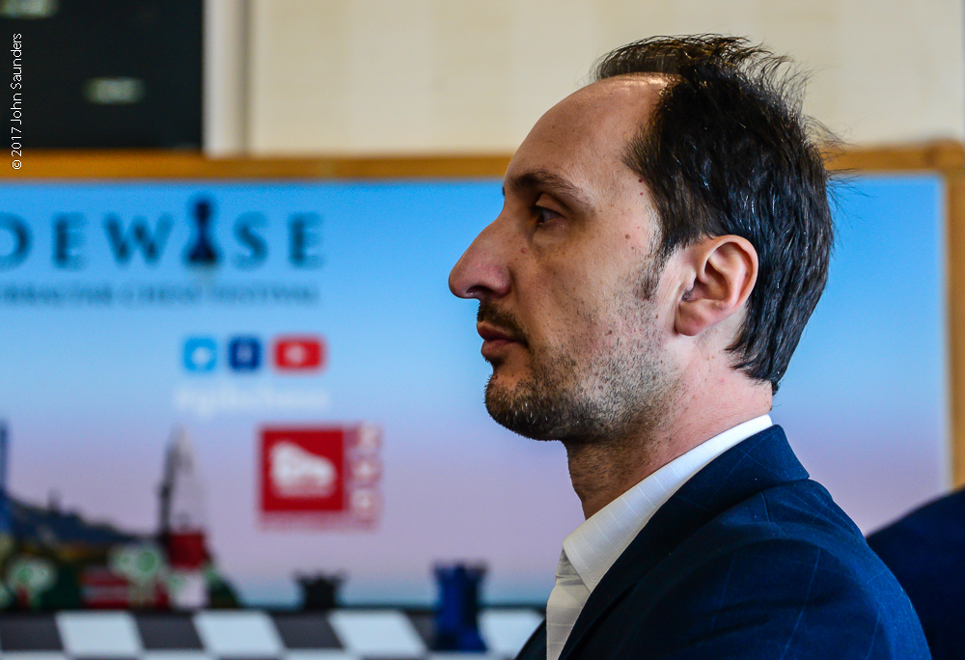

*A pensive Veselin Topalov before the ninth round, in which he played well below par.*

David Antón Guijarro's win against Veselin Topalov seemed relatively smooth after another display of controlled, positional chess from the 21-year-old Spaniard. He defended an orthodox Ruy Lopez/Spanish opening, rather than resort to the Berlin, and was rewarded for his more positive choice of opening as Topalov failed to put any pressure on his position, allowing an easy equality. Topalov's play seemed insipid, almost as though he didn't care about the game and was focused on something else. This impression was strengthened by an early resignation in a position where it was likely that he would lose but in which you would expect him to pose his opponent a few more problems before throwing in the towel. There are other things in Topalov's life these days, notably fatherhood, and this game did make me wonder whether the man who brought down the curtain on Garry Kasparov's professional career might himself be contemplating retirement.

*Tradewise Gibraltar Masters, Round 9, 1 February 2017*

**V.Topalov (2739) - D.Antón Guijarro (2650)**

**1.e4 e5 2.Nf3 Nc6 3.Bb5 a6 4.Ba4 Nf6 5.0‑0 Be7 6.Re1 b5 7.Bb3 d6 8.c3 0‑0 9.h3 Na5 10.Bc2 c5 11.d4 Nd7 12.Nbd2 exd4 13.cxd4 Nc6 14.d5 Nce5 15.a4 Bb7 16.Qe2** 16.Nxe5 Nxe5 17.f4 Nd7 18.Nf3 Re8 was Topalov's choice against Adams in the Cap d'Agde rapidplay in 2003. The text appears to be new, and more circumspect. **16...Rb8 17.Nxe5 Nxe5 18.axb5 axb5 19.Nf1** Topalov's 2003 plan with 19.f4 seems more his style. **19...Re8 20.Ne3 Bf6 21.Bd2 Bc8**

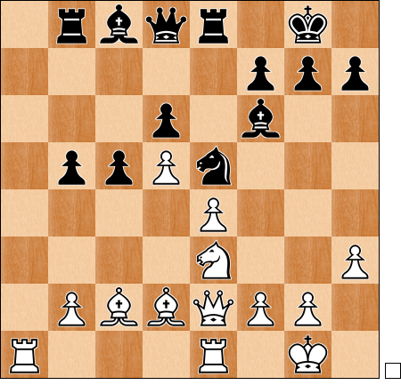

After the game Anton thought he had been given an easy ride at the start of the game. White doesn't appear to have achieved anything from the opening, indicating a possible lack of preparedness. **22.Ba5** Anton thought the plan of Ba5 followed by Bc3 was "too slow as he didn't have enough time to play g3 and f4". **22...Qe7 23.Bc3 Ng6** "I controlled f4 and e5 and it seemed very easy for me to play" )Anton) **24.Qf3 Bxc3 25.bxc3 Qg5 26.Kh2 h5 27.Ra7 Re7 28.Rxe7 Nxe7 29.Ra1 Ng6 30.Qg3?!** This allows Black to attack the c-pawn with his queen and more or less force an advantageous exchange of minor pieces. **30...Qf6** The threat now is not Qxc3 (which would allow Qxd6) but b4, exploiting the loose rook on a1. **31.Nf5** White's instincts are to go forward but 31.Nd1 might be more prudent, despite giving rather an ugly impression. **31...Bxf5 32.exf5** Black is now a virtual pawn up on the queenside. **32...Ne5 33.Rb1 h4 34.Qf4 g5 35.Qe3 Nc4 36.Qc1 Kg7 37.Bd3 Ne5 38.Be4 g4 39.hxg4 Nxg4+ 40.Kg1 Qh6 41.Qxh6+ Kxh6 42.Kf1 Kg5 0‑1**

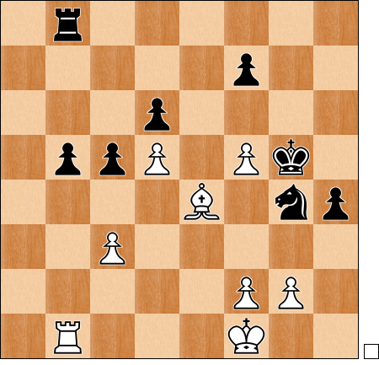

White resigned in the above position. More than a little surprisingly, since material is still level and the winning plan not yet absolutely clear. "I was a bit surprised by his resignation. It seems completely winning, the material is equal but it is very easy for me to play, Kg5 and b4, and he's playing for nothing." (Anton) Even so one could hardly envisage the Topalov of ten years ago not giving it everything to save the game.

Mickey Adams beat SP Sethuraman in an entertaining game, though one in which Black had a chance to exploit a move order error on move 19 had he seen a computer move. White's exchange sacrifice, backed up by incisive positional play, saw him through.

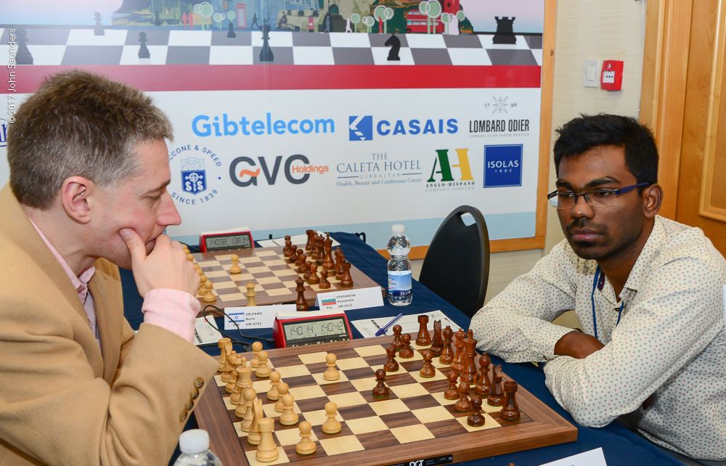

*Mickey Adams patriotically opens with the English against SP Sethuraman*

*Tradewise Gibraltar Masters, Round 9, 1 February 2017*

**M.Adams (2751) - S.P.Sethuraman (2637)**

**1.c4 e5 2.g3 c6 3.d4 e4 4.Nc3 d5 5.Bg2 Nf6 6.cxd5 cxd5 7.Bg5 Nbd7 8.Qb3 Bd6 9.Nh3 h6 10.Bf4 Nb6 11.Be5** So far Mickey Adams is following the moves of a game played by an English amateur player, Andrew Stone, in a tournament in Austria last year. **11...Ng4** Taking the game out of the book **12.Bxg7 Rg8 13.Be5 Nxe5 14.dxe5 Bxe5 15.Rd1 Be6**

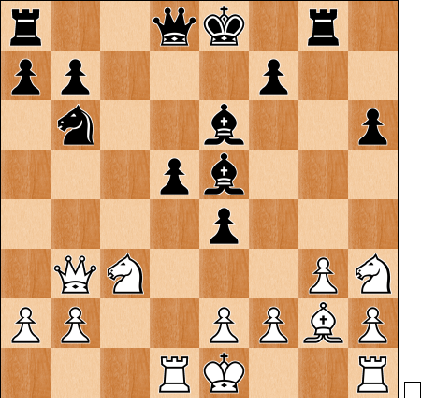

**16.Nxe4!?** This move involves the calculation of a long line leading to an exchange sacrifice. There is a flaw in the execution, however, but both players were oblivious to this until informed of it after the game by those who had access to computer analysis. **16...Qc8 17.Nf4 dxe4** 17...Bxf4 18.Nf6+ Ke7 19.Nxg8+ Qxg8 20.a4 and the computer prefers White. **18.Qb5+ Nd7 19.Rxd7?**

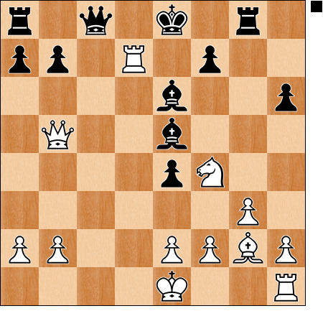

A move order mistake by White. In fact, after 19.Nxe6 fxe6 20.Rxd7 Qxd7 21.Qxe5, his plan remains on course and he has enough compensation for the exchange sacrifice. **19...Qxd7?** Here Black had the chance to play 19...Bxf4 and the computer is satisfied that Black emerges with a material advantage. It forms a remarkable twin with Hou Yifan's win in round seven where she allowed her opponent a visually devastating double check opportunity with queen and rook on a diagonal. As regards this game, it is quite understandable that the players should have overlooked it since some of the sub-variations would require the sort of computing power that is beyond the capability of the organic brain, e.g. 20.Rc7+ (20.Rd1+ Bd7 21.Qb4 Bc6 22.Bxe4 a5 23.Qc4 Be5 is probably winning for Black) 20...Bd7 21.Rxc8+ Rxc8 and White is faced with an attack on his queen and the threat of Rc1 mate. **20.Qxe5 0‑0‑0 21.0‑0** White has thus sacrificed rook for knight and pawn, but he also has compensation by way of pressure against the e4–pawn and the immediate threat of Rc1+. In fact, a second pawn must go. **21...Qc7 22.Qxe4 Kb8** 22...Bxa2 allows 23.Qa4 and the capture of the a7–pawn, while various other bishop moves allow Nd5 and Ne7+ regaining the exchange. **23.Nxe6 fxe6 24.Qxe6 h5 25.Qf6 Rdf8 26.Qh4** Not the sort of position Black would want to have against a player of Adams' style and calibre. **26...Rf5 27.Bf3 Rd8 28.Kg2 Rc5 29.b4 Rc4 30.Qxh5 Rxb4** Now White has a potential array of four connected passed pawns though, typically, White is in no hurry to deploy them all as some of them are better used to protect his king. **31.Qg5 Qd6 32.Rc1 a6 33.h4 Rb5 34.Qg7 Rd7 35.Qh8+ Rd8 36.Qc3 a5 37.h5 a4 38.h6** A small tactical device designed to exchange the h-pawn for Black's a-pawn and also to gain more activity for the white rook. **38...Qxh6 39.Qc7+ Ka7 40.Rc4** With his d8 rook attacked, Black can't hold the a-pawn. **40...Rd6 41.Rxa4+ Ra6 42.Rh4 Qf8 43.a4 Rb4 44.Rf4! 1‑0**

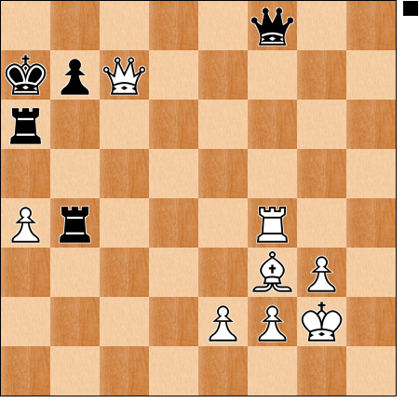

An unusual trick, effectively forking queen and rook with a rook, since the b4 rook cannot move off the b-file because of the threat of mate on b7.

Antoaneta Stefanova had enjoyed a fine tournament to date but her rather passive play with a sort of Pirc/Modern set-up was punished by a classical central files attack from Boris Gelfand, who thus puts himself within half a point of the lead. David Howell might have reached the same score but he was kicking himself after the game for not exploiting an early middlegame advantage against Maxim Matlakov and later even had to fight to save the half-point.

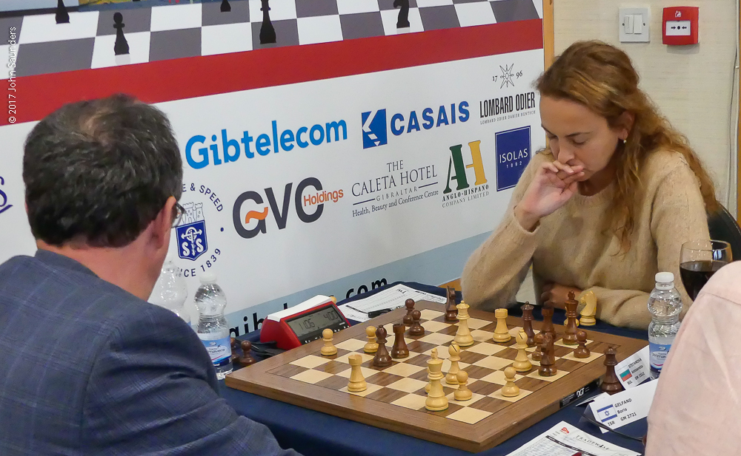

*Boris Gelfand put paid to Antoaneta Stefanova's chances of winning the £15,000 women's prize*

After seeing his fellow Bulgarians fall by the way, Ivan Cheparinov kept his national flag flying with a win against Daniel Fridman of Germany. After frittering away an early advantage it looked as if the game must be drawn but then Black fell for a well-concealed tactic.

*Tradewise Gibraltar Masters, Round 9, 1 February 2017*

**I.Cheparinov (2689) - D.Fridman (2594)**

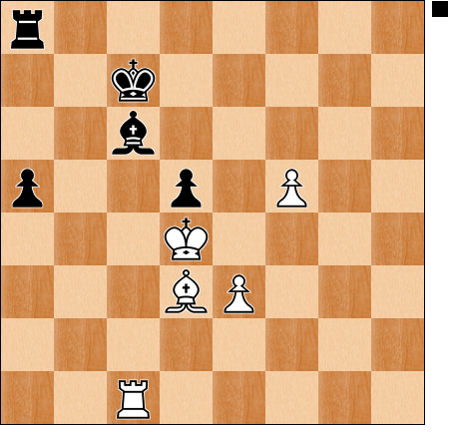

**72...Kd6??** With care it looks as if Black should be able to draw from this position, and he probably would have done had he played 72...Rb8 but the very natural looking text move is savagely punished. **73.e4!! a4** The point is that 73...dxe4 loses to 74.Rxc6+! Kxc6 75.Bxe4+ skewering the rook on a8, with an easy. Since Black cannot capture the e4–pawn, it means that it will advance to become a passed pawn. Worse still for Black, White will have a connected passed pawn spearhead to which there is no defence. **74.e5+ Kd7 75.f6 a3 76.Bf5+ Kc7 77.f7 a2 78.Ra1 Ra4+ 79.Ke3 d4+ 80.Kf4 Ra8** 80...d3+ 81.Kg5 Ra8 82.Rxa2! is equally hopeless. **81.Rxa2 Rf8 82.e6 Kd6 83.Ra6 d3 84.Ke3 Rd8 85.Rxc6+ Kxc6 86.e7 1‑0**

Nigel Short's chances of the top prize were snuffed out by French GM Romain Edouard. Short, playing Black, advanced his g-pawn in front of his castled king, allowing a piece for pawns sacrifice by Edouard, backed up by a powerful central pawn advance, winning back the piece. This afforded Edouard a big positional plus which he converted with some ease.

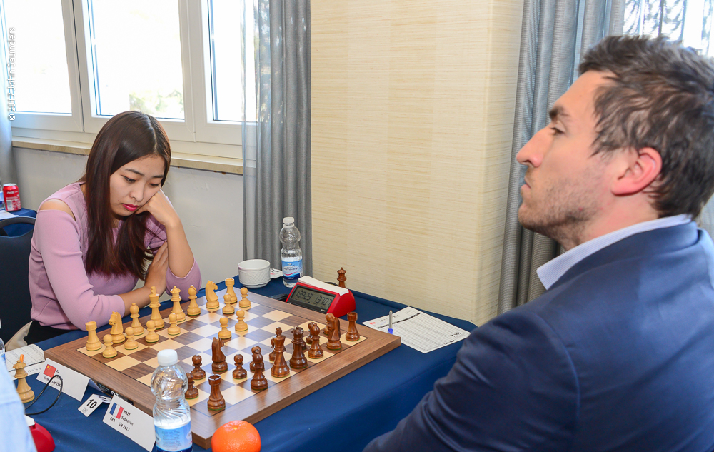

*Ju Wenjun improved her TPR to 2785 by beating Sébastien Mazé.*

Ju Wenjun is having a wonderful tournament and her victim in round nine was French GM Sébastien Mazé. The Frenchman wasted time trying to relocate a knight in the opening (a Fianchetto King's Indian) and that was all the encouragement the brilliant Chinese player needed to launch an assault against him. Mazé found himself obliged to surrender the exchange and his attempts to conjure up counterplay were easily rebuffed. Subject to some mathematical permutation of which I am unaware (and to the confirmation of the arbiters, which I don't yet have), Ju Wenjun looks a certainty for the £15,000 women's first prize, and of course she remains in the running for the £23,000 first prize itself.

Please note that round ten starts at the earlier time of 11am on Thursday.

Photos of round 9 by John Saunders: <https://flic.kr/s/aHskTGxRzR>

Photos of round 9 by Sophie Triay: <https://flic.kr/s/aHskRmWrRU>

Video footage and interviews from today's round are available to embed from our [YouTube Channel](https://www.youtube.com/channel/UCa1RTZ95_wMc5dbzI8ugTEQ).

*Report Ends*

**Official website:** [**www.gibchess.com**](http://www.gibchess.com)

[**YouTube Channel**](https://www.youtube.com/channel/UCa1RTZ95_wMc5dbzI8ugTEQ)

*John Saunders*

*Press Reporter, Tradewise Gibraltar Chess Congress*

*Official website:* [*www.gibchess.com*](http://www.gibchess.com) *- Twitter @GibraltarChess*

*Personal Twitter Account @johnchess*