**What were the reasons for BBCA’s formation?**

In June 2015, some like-minded former chess players met at a social gathering where we were discussing the socio-economic and political issues of the UK and how they affect people, particularly young and older people.

This was a time when gang culture, including drug abuse and hate crime was surging among inner city estates, particularly in Tower Hamlets and Newham. High-minded politicians and the media were condemning this trend. Councils were closing down youth clubs/centres, leisure facilities, cultural activities and after-school club provisions, including language classes. Councils were complaining that they had no funding from central government to run these projects. For their part, ministers stated that the country was experiencing the worst economic recession in history, so no funding could be given to ‘non-essential’ sectors.

Drug dealers work like vultures, looking for vulnerabilities in children to entice them. Poor living standards, lack of job opportunities, extreme overcrowding in social housing, the highest teenage pregnancy and worst child poverty in Western Europe and lack of positive role models bring frustration and helplessness. Young people become easy prey.

As a teacher, I see many such children. I ask why they are ‘on the street’ – their reply is simply ‘no choice’. They have nowhere to go, nowhere to hide. If they want to hire the AstroTurf football pitch in Stepney Green it would cost £150. Badminton courts are invariably pre-booked. The council has sold off green areas adjacent to estates to developers for knockdown prices. They are making a fortune and City folk are buying the luxury flats. People are living without hope in a concrete jungle.

These youngsters are growing up in between three major financial hubs of London. The City of London has 17.5 per cent of the country’s workforce; Canary Wharf has employed 120,000 people, and Stratford is going through a regeneration project worth millions. But how much have the corporate companies invested for the children of Tower Hamlets?

This is the background to us forming the British Bangla Chess Association. We actively promote chess to create peace and harmony in our society. Although chess is not a popular sport in ethnic minority communities we are promoting the game as an alternative to their current lifestyles. We believe chess is the best weapon in our fight against racial prejudice, intolerance and religious extremism. We are creating a harmonious coexistence in our club and tournaments.

**Tell us about the activities you run**

Every Sunday at 3pm, we meet at the Tower Hamlets Parents Centre, 1 Links Yard, 29 Spelman Street, London E1 5LX (off Brick Lane) where we play and learn chess. On the last Sunday of each month, we organise a Rapidplay that has become a popular event among local players.

We also organise the annual BBCA International Rapidplay, a popular, daylong, fun-filled occasion. Last year, 120 players from 27 nationalities, competed in two sections for £2,000 prize money and enjoyed traditional hospitality with a quality lunch and unlimited refreshments. We have organised three large events and 30 smaller events in the last two and a half years.

**What are your short and long-term aims?**

We would like to immediately start a proper coaching programme for children and for adults. Our members are now ready to move to the next level so we need a good coach at an affordable rate.

Our members are winning tournaments London so we have a nucleus. Our goal is to see our members winning nationally, internationally and representing England in the Olympiad.

It may be a dream to think of an east Londoner as British Champion but with a structured training programme, commitment and perseverance, who knows what could happen in 15 years? Youngsters from east London are as talented as anywhere in the world.

**Do you get any funding other than membership fees?**

Unfortunately, not. We cover the running costs of our club from voluntary contributions of our committee members. We started a membership fee from January 2018 at a very competitive £10 per year. Previously, it had been free. We also provide ample refreshments for players in each practice session and we cover London Chess League fees, Summer Chess League Fees for our teams. Our monthly tournament fees are £5 for BBCA members and £7 for non-BBCA members and we return 100 per cent of takings to the winners.

Promises from a local entrepreneur and council have yet to materialise but the Tower Hamlets Parents Centre and London Enterprise Academy have provided their venues at no cost. Some small Bangladeshi businesses and charity organisations have supported our international tournaments – we express our gratitude to these remarkable supporters of chess.

**What are your hopes for the new London League team you are running?**

In 2017, we played in London Summer Chess League and our team East London Knights became champions. This success inspired us to take part in this year’s London Chess League. We have played in Division 4 and we are proud to be this season’s champions with an impressive 10-1-1 record.

In August we are planning to take our winning team to the British Championships in Hull to take part in the Sunday Rapidplay. We are grateful to London Tigers for meeting the transport costs.

**Do you think chess can be a positive force for change?**

Chess is a curriculum subject in many of our primary and secondary schools. Research shows that playing chess improves students’ social skills, memory, spatial skills, numerical abilities, verbal skills, creative and critical thinking, problem solving and reasoning skills. Chess provides health benefits as it exercises both sides of the brain. It also helps prevent Alzheimer's disease.

While learning and playing chess in an academic or a club setting provides a fun engaging exercise in strategic thinking. These brain-building benefits remain and support learners long after chessboards have been put away.

Also, children learning and playing chess in our club and my school display a significant improvement in behaviour. They have developed a growth mindset, hard-work ethic and importantly their academic performance is improving. This is a win-win situation for schools, parents and children.

At club level, chess creates community cohesion and tolerance allowing us to be motivated, self-reflective learners ready for life’s challenges.

**Your London League team that gas done so well in Division 4 is made up of players from different backgrounds, not only from the British Bangladesh community. How have you achieved such a diverse range of players?**

As an open club that embraces diversity, we welcome anyone who loves chess. The word Bangla on our club name comes from the Bangla Town Ward of Tower Hamlets Council where the early immigrant communities settled. We belong to that history and heritage. Our players are part of this philosophy. Put simply, we are lovers of chess.

**Can your model of starting up BBCA help other clubs?**

We have just started our journey and we are learning from other clubs and leagues. One thing has surprised me when I first went to play in the London League – players were predominantly white and over 40 years old. I think clubs should also attract younger players and those from minority and ethnic communities.

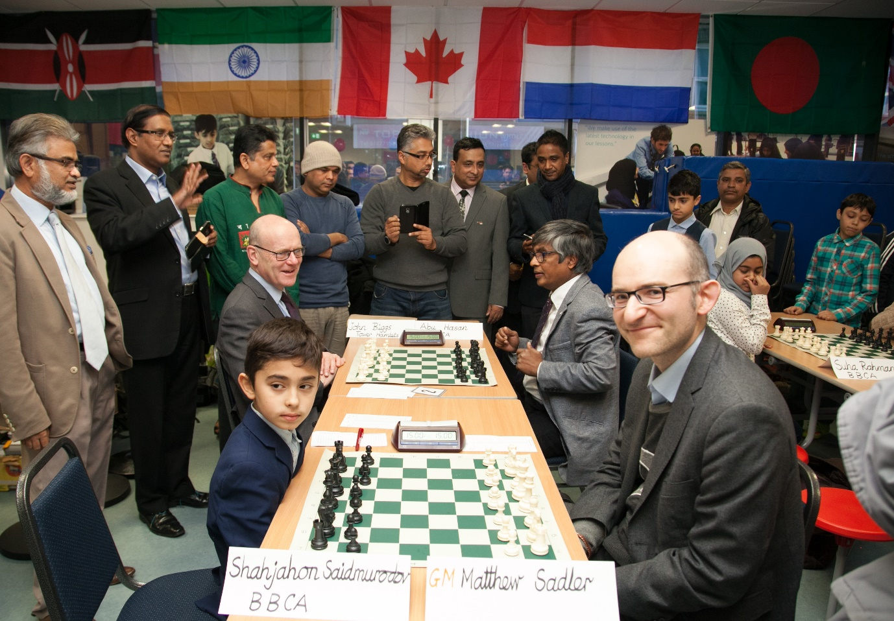

*BBCA International Rapidplay 2016: John Biggs, Executive Mayor of Tower Hamlets plays Abu Musa Hasan, Chief Adviser of BBCA. Chess prodigy Shahjahon Saidmurodov is ready to take on GM Matthew Sadler.*

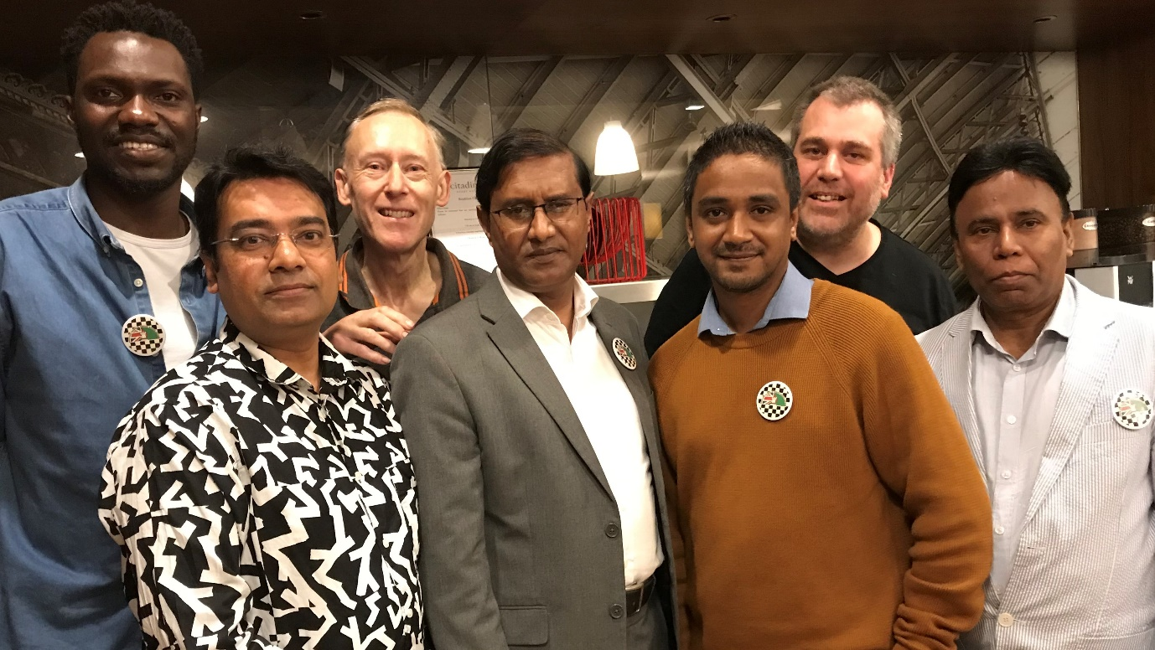

*Check mates: BBCA players following their final London League Division 4 match.*