Grades and Ratings

1. FIDE Rapidplay ratings from the March 2019 list will be used for all sections, and ECF Rapidplay grades published in the January 2019 list will be used for players unrated by FIDE. If rapidplay grades are not available then ECF standard play grades will be used instead.

2. Players will be placed into sections based on the higher of their FIDE rapidplay rating or ECF rapidplay grade.

3. All sections will be both FIDE rated and ECF graded.

4. Players without a current FIDE rating or ECF grade must give details of estimated playing strength, including any previously held grading, or current grading from another body. These players will be assigned a grade by the organisers for the purposes of determining what section they will play in.

5. Ungraded or unrated players may not win a best performance prize and, with the exception of the FIDE Open, may only win 25% of any other prize.

Notices

1. There is a pay to play fee of £7.50 for players who are ECF Bronze members or who are non-ECF members (this includes visitors from outside of England). This has been incorporated into the Entry Fees advertised.

2. Prizes may be changed subject to the number of entries.

3. The Chief Arbiter reserves the right to transfer players between tournament sections at any time.

4. The submission of an entry form and payment of the entry fee denotes acceptance that the Chief Arbiter’s decision is final in all matters.

5. Chester Chess Club reserves the right to refuse any entry without explanation.

Accommodation

Accommodation (from hotels to budget choices) can be found upon the Visit Cheshire website for those who wish to make a weekend of visiting the historical city of Chester:

https://www.visitcheshire.com/accommodation

How to Get There

Bus: The Stagecoach X8 runs from Chester Railway Station to (close to) Upton High School and takes approximately 10 minutes.

Walk: The walk from Chester Railway Station takes approximately 40 minutes. From Bache Station the walk takes 30 minutes.

Car: Upton High School is located just off the A41, between Chester Zoo and the Hoole Roundabout, 1½ miles NNE of the city centre. There is ample on-site parking.

Control Team

Chief Arbiter: Matthew Carr

Tournament Team: Graham Bromley
Phil Crocker
Chris Doran
Steve Lloyd
Mike McDonagh

Disclaimer

Chester Chess Club accepts no responsibility for any damage, theft or accident to the person or property of anyone attending this event.

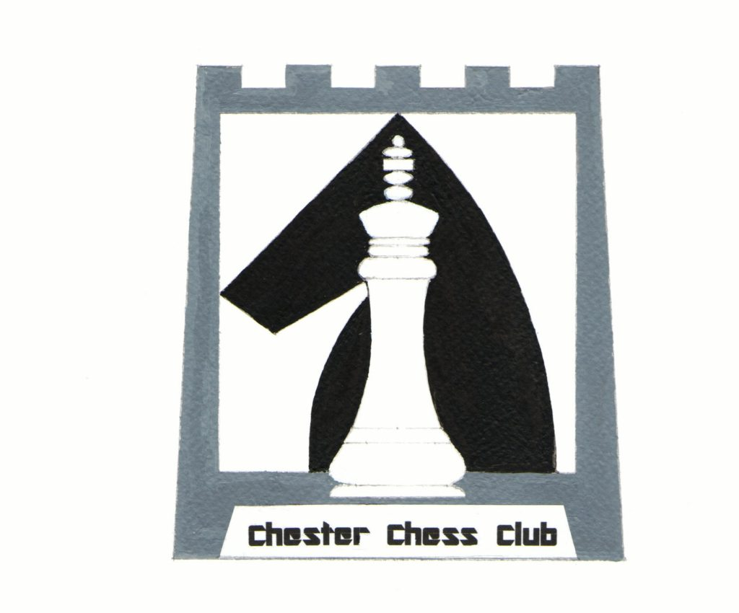

CHESTER CHESS CLUB CENTENARY RAPIDPLAY

Sunday 7th April 2019

Celebrating 100 Years of Chester Chess Club

Upton-by-Chester High School
St James’s Avenue
Upton
Chester
CH2 1NN

FIDE Rated Open
FIDE Rated U1900 Major
FIDE Rated U1600 Minor

Prize fund £1,340

www.chesterchess.co.uk

Tournament Sections

FIDE Open

Open to all players

Prizes: 1st £250, 2nd £100, 3rd £50,
Highest scoring player rated under FIDE 2000 / ECF 174: £40
Highest ranked Junior: £40
__________________________________________

FIDE U1900 Major

Open to players graded below FIDE 1900 / ECF 160

Prizes: 1st £200, 2nd £100, 3rd £50
Highest scoring player rated under FIDE 1750 / ECF 140: £40
Highest ranked Junior: £40
________________________________________

FIDE U1600 Minor

Open to players graded below FIDE 1600 / ECF 120

Prizes: 1st £200, 2nd £100, 3rd £50
Highest scoring player rated under FIDE 1450 / ECF 100: £40
Highest ranked Junior: £40
________________________________________

Entry Fees

Adult Junior
ECF Bronze or Non-Member £27.50 £22.50
ECF Silver, Gold, Platinum Member £20.00 £15.00
__________________________________________

Pay to play fees incorporated into listed fees – Please see Notices section above.

No player may win more than one prize. All place prize money will be shared equally between tied players.

For the purposes of the tournament a Junior is defined as being under 18 on the 1st of February 2019.

Team Prize

For teams of four who are genuine members of a club, with the best three scores to count. Prize: a digital clock. You will need to have submitted your team before the commencement of Round 2.

Entry Forms & Payment

Completed entry forms, together with the appropriate entry fee (payable to “Chester Chess Club”) should be sent either to Graham Bromley (see below for his address) or sent via email to:

congress@chesterchess.co.uk

Payment by bank transfer: Chester Chess Club, Sort Code: 09-01-50, Account Number: 03474313. Please put your surname & forename in the reference field. This method of payment is preferred.

Cheques & Postal Orders should be made payable to Chester Chess Club and sent with your entry form to: Graham Bromley, 30 Knowsley Road, Hoole, Chester, CH2 3RL.

Late Entries

Entries may be accepted on the day subject to availability and payment of a £10 surcharge. Entries submitted after the 30th of March 2019 will also be subject to this charge if accepted.

Playing Schedule

Round 1 10:00 am Round 4 2:10 pm
Round 2 11:20 am Round 5 3:30 pm
Round 3 12:40 am Round 6 4:50 pm

Players may request a First Round ½ point bye at time of entry.

Time Control

Each player will be allowed 20 minutes for all their moves + 10 seconds per move.

Re-pairing will take place 10 minutes after the start of a round. Players who have not arrived will be defaulted 10 minutes after the scheduled start of a round.
Entry Form

Chester Centenary Rapidplay (7th Apr 2019):

- FIDE Open

- FIDE U1900 / ECF U160 Major

- FIDE U1600 / ECF U120 Minor

Name_____________________________________

Address____________________________________

__________________________________________

Telephone__________________________________

Email______________________________________

Club______________________________________

ECF Rapidplay Grade________________________

ECF Grading Code___________________________

ECF Membership Category____________________
(non-member, Bronze, Silver, Gold, Platinum)

FIDE Rapidplay Rating________________________

FIDE Code_________________________________

ECF Membership No_________________________

Federation__________________________________

Date of Birth (Required for Juniors)______________

Bye required in Round One (please circle) Y / N

Entry Fee: £________________________________

Donation: £_________________________________

Total Enclosed: £____________________________

Submission of this entry form denotes that I have read and agree to the congress’s terms and conditions.

