Director of Home Chess Report Nigel Towers
ECF Online - ECF online club memberships continue to increase on chess.com and lichess with the latest events schedule available at the usual link as below:
https://englishchessonline.org.uk/upcoming-club-events/
ECF Members club tournaments are all ECF online rated along with registered league, club and congress events including 25 or so local leagues as you can see from the Events list for March online rating. These are increasingly popular and you may want to check out some of the leagues which present a great opportunity to play against local players online in team events at a range of time controls.
https://englishchessonline.org.uk/ecf-online-ratings-march-2021/events-during-february-rated-in-the-march-list/
Nations League - The chess.com Nations League season II has now completed with the England team finishing a creditable 6th in the highly competitive top division including a draw against third-place USA.

 Nations League Final Standings

 | Name | Rd 1 | Rd 2 | Rd 3 | Rd 4 | Rd 5 | Rd 6 | Rd 7 | Total
1 | Romania | W6 | W2 | W4 | W8 | W3 | W7 | W5 | 7.0
2 | Poland | W3 | L1 | D5 | W6 | W4 | W8 | W7 | 5.5
3 | United States | L2 | W7 | D6 | W5 | L1 | W9 | W10 | 4.5
4 | Canada | W7 | W11 | L1 | W9 | L2 | L5 | W6 | 4.0
5 | Uruguay | W12 | D9 | D2 | L3 | W8 | W4 | L1 | 4.0
6 | England | L1 | B--- | D3 | L2 | W10 | W11 | L4 | 3.5
7 | Argentina | L4 | L3 | B--- | W11 | W9 | L1 | L2 | 3.0
8 | Saudi Arabia | D11 | W10 | D9 | L1 | L5 | L2 | B--- | 3.0
9 | Jamaica | W10 | D5 | D8 | L4 | L7 | L3 | D11 | 2.5
10 | Cape Verde | L9 | L8 | D11 | W12 | L6 | B--- | L3 | 2.5
11 | Greece | D8 | L4 | D10 | L7 | W12 | L6 | D9 | 2.5
12 | Pakistan | L5 | U--- | U--- | L10 | L11 | U--- | U--- | 0.0
 Saturday Masters - The ECF English Players team is also taking part in the regular lichess.org Saturday Masters events at 4-00 pm on Saturday afternoons. These are team battles at 3|0 blitz time control with 30 or more national teams, open to all ECF members/ supporters and running for 90 minutes. We regularly finish in the top places and GMs Matthew Sadler and Keith Arkell led the way last Saturday,3rd April, with the England team finishing sixth in the strongest field to date. Please see below for the results from last Saturday and team leader board as at April 7.
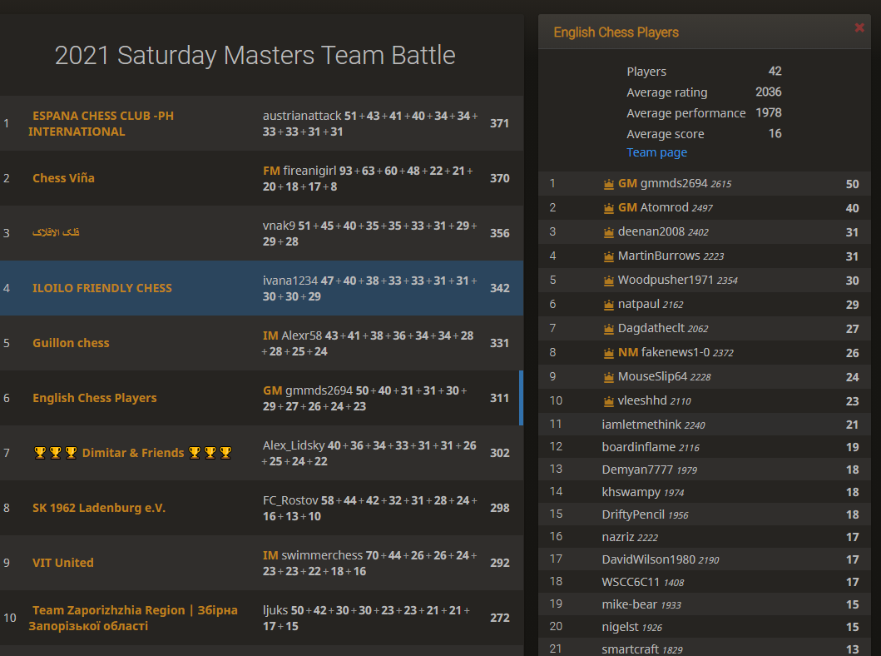
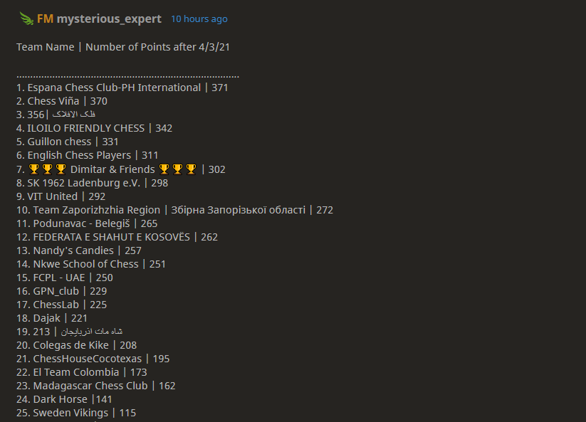
ECF Online Grand Prix – The ECF Online Blitz and Rapid Grand Prix Series continue with some well subscribed events on the lichess.org platform. The first Rapid tournament attracted a field of over 120 players in a very competitive event with winners as below:
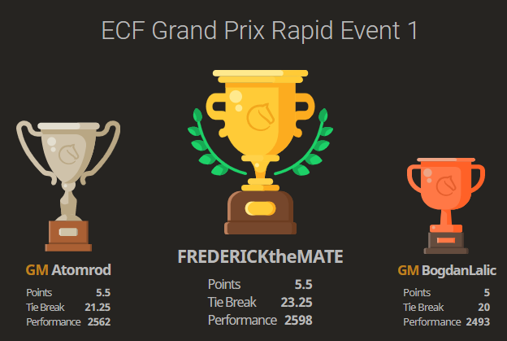
We are publishing a leader board which is updated following the events, with prizes for the winners in eight categories at the end of each series including Open, Women’s, Senior, Junior, U2000 U1700, U1400, and U1100.
Please see the links here to enter either series.
Online Blitz Grand Prix - https://britchess.wufoo.com/forms/m1umalxs00wt7hj/
Rapid Grand Prix - https://britchess.wufoo.com/forms/mn0wucv0iq3nkv/
Online Events – 2021
We plan to continue with some major online events over the coming months. These can be found in the summary ECF Online calendar here:
https://englishchessonline.org.uk/ecf-national-events/ecf-online-national-events-calendar-2021/
Two events of particular note are:
ECF Chess for All - , The English Chess Federation is launching a Chess for All Festival to take place on chess.com from Sunday 30 May – Friday 4 June, followed by the 2021 'Rematch' Marathon on 5th and 6th June. There will be training, streams and tournaments all tailored to two distinct groups: beginners and improvers. More details from organiser Danny Rosenbaum elsewhere in the Newsletter.
2021 British Online Championships II- 24 July - 8 August 2021
This will follow much the same format as BOCC-I over Christmas 2020 and will include Qualifiers and Finals for the 2021 British Online Open, Women, Seniors and Junior Championships. We will also be running Major Open and Rating Limited online competitions over the same period. Please follow the link to the BOCC-2 web page here for more details - https://www.englishchess.org.uk/british-online-chess-championships-2021/. The entry form will be available shortly.
Over the Board Events - 2021
We are now planning a number of Over the Board Events for 2021.
English Counties 2021 – We are looking to schedule some friendly county events for August and September 2021 which will be open to all counties and with the potential to use some new formats including hybrid team matches, dependant on feedback from associations and the progress of the opening up process. All being well we are planning for the 2021/2022 OTB counties season to start in earnest with regional stages starting in October and finals next year.
British Championships 2021 - 2 Oct - 10 Oct
The over the board championships are now scheduled for October at two or three separate venues covering Open, Women, Seniors and Juniors Finals, with Seniors and Juniors co-located and on different days. The events will run daily during the week and weekends, with the junior finals over the weekend of 2nd and 3rd October. Qualifications will be based on the 2021 summer online competition with those who qualify for a final invited to play. For the Championship we are also considering whether or not we can invite those who qualified for the 2020 OTB or if these should be deferred to the 2022 Championship in Torquay. There may also be a Major Open and rating limited competitions at an additional venue alongside the other events, or possibly in February 2022, and dependant on player feedback and level of interest.
New to Chess - As well as the elite events we are also looking at how we can support new players who are looking to take up the game following The Queen’s Gambit Netflix series. The latest version of our New to Chess Page now includes general advice, web and coaching/ educational resources and can be found here:
https://www.englishchess.org.uk/new-to-chess/
Arbiters – We have an arbiters course scheduled for April covering over-the-board and online arbiting and have published the new set of ECF online arbiter duties and levels which you can find on the web site here:
https://www.englishchess.org.uk/arbiters/ecf-arbiters/
Registered Coaches Scheme – This is now up and running thanks to IM Andrew Martin and supporting team, and is proving very popular with a number of coaches now registered and listed on the ECF web site. You can find further details here:
https://www.englishchess.org.uk/list-of-ecf-registered-coaches/

