**NORTHUMBERLAND WEEKEND CHESS CONGRESS 2020**

**ANTI COVID MEASURES and CONGRESS IMPACTS**

**NORTHUMBERLAND CHESS ASSOCIATION**

Promoting chess in the North East Since 1930



Author : Mick Riding

mickriding@hotmail.co.uk

**Contents**

1. INTRODUCTION 2

2. KEY BULLET POINTS 3

3. REFERENCES 3

4. ANTI COVID PROCEDURES 4

5. PLAYING SET UP 6

6. IN BETWEEN ROUNDS 7

7. CHANGES TO CONGRESS 7

8. CONCLUSION 7

APPENDIX A – PLAYING ARENA FLOOR PLAN 8

APPENDIX B – MEDICAL CHECKLIST 8

APPENDIX C – ONGOING ACTIONS 9

APPENDIX D – HISTORY OF CHANGES 10

# INTRODUCTION

On 17/09/2020 a number of North East districts went into Local Lockdown. North Tyneside was one of these and as a consequence the Northumberland Weekender was cancelled for 2020. This document is written on the pretext that the Congress was going ahead on 25/09/2020 and details the activities that were ongoing leading up to Lockdown. Its purpose now is to (hopefully) provide other Congresses with a platform against which to develop their own measures and mitigate some re-inventing of wheels.

1.1 The purpose of this document is to try and encapsulate all the safety precautions being taken by the Northumberland Congress in the light of the 2020 Covid-19 (Covid) pandemic and necessary impacts to the congress required to facilitate these.

1.2 The Owner of this document is the Northumberland Congress Tournament Controller.

1.3 The Approvers of this document are –

* North Tyneside Council (NTC) – who will ensure the Congress’ proposals meet Local and Government Covid safety guidelines
* The Chess Playing Community – who will decide by entering or not entering whether the document reflects their own personal safety requirements. It will be a prerequisite of entering that the entrant has read this document. Existing entrants reserve the right to withdraw if on reviewing this document they are not satisfied with the arrangements in place. Entrants should be aware that Government advice is constantly changing and therefore this document will too. It should therefore be constantly referred to.
* The Northumberland Chess Association (NCA) will advise the Owner on measures that may be included and/or enhanced to further consolidate what is being proposed before approving for ratification by NTC.

1.4 Three professional NHS staff are being consulted with respect to some of the anti-Covid steps in this document including

* A Doctor
* A Nurse
* A Radiographer

All of who have had direct contact with patients suffering with Covid since the pandemic arose. Indeed, at the time of writing the nurse still works on a Covid dedicated ward. Appendix B is a table reflecting their advice and how we propose to address that.

1.5 The document will be a work in progress until such time as the Government of the day advises society can fully return to its pre-Covid state. For the purpose of baselining – the version of the document that is active at the time of the Congress will be regarded as the baselined version.

1.6 After the Congress entrants will be canvassed and a review undertaken. Any changes deemed necessary will be reflected against this document.

# CURRENT STATUS

2.1 As at 12/09/2020 the NTC team at The Parks venue are happy the congress can go ahead. They have offered a range of support including individual sanitisers and other cleaning equipment, floor markings, printer facilities and advisory posters. It is appropriate that we acknowledge their fantastic support and spirit of co-operation at this point.

2.2 The Council importantly engage other bodies responsible for public health and safety such as the Director for Public Health and Northumberland police. Thus anybody who needs to know what’s going on does.

There are currently 67 entrants across the three sections. So…..

Subject to a local lockdown the congress is going ahead.

# KEY BULLET POINTS

The document will go into more detail with respect to various issues arising from the Covid threat and playing of chess as proposed in this paper. But because of the seriousness of the threat some key points are being re-enforced here for your specific attention –

* Please do not attend the congress if in the fortnight leading up to the congress you have experienced Covid-19 symptoms or have been living with anyone experiencing the same and not been tested as negative
* Players entering do so at their own risk. We are taking what mitigation we can but ultimately to enter or not is your decision. Parents of any entrants under the age of 18 will be contacted directly by the congress to provide this assurance.
* The playing environment is single board with no dividers. Although we do adhere to current government guidelines as best we can at any given time. There is no ‘two board’ option.
* Government guidelines are changing every day. Whilst we will try and keep abreast of these and co-ordinate our understanding and any impacts with NTC – you, the entrant, must share this responsibility too.
* The Open tournament is not FIDE rated. All sections are the same playing schedule to support time required for cleaning activity in between rounds.

# REFERENCES

4.1 NTC, the Congress Organiser and delegated authorities will constantly be referencing [https://www.gov.uk/coronavirus?gclid=CjwKCAjwjqT5BRAPEiwAJlBuBYSgaQB68e6ZiDrhHpALYxwkT RXOBTemVFzyKWz8oOwkdGTyaIilEmxoCJIkQAvD_BwE](https://www.gov.uk/coronavirus?gclid=CjwKCAjwjqT5BRAPEiwAJlBuBYSaQB68e6ZiDrhHpALYxwkTRXOBTemVFzyKWz8oOwkdGTyaIilEmxoCJIkQAvD_BwE) to ensure the proposed protocols continue to adhere to Government Covid-19 Guidelines.

4.2 The link <https://www.bbc.co.uk/news/uk-51768274> advises of the current Covid situation/statistics in your home area

4.3 This document has also been validated against the English Chess Federation Risk Assessment Template <https://www.englishchess.org.uk/wp-content/uploads/2020/07/OTB-Chess-Risk-Assessment-v4.pdf> to confirm completeness/compliance.

4.4 Finally the author has also referenced the 2020 Irish Championship - [https://www.icu.ie/articles/906.](https://www.icu.ie/articles/906) Of course there are differences between the Irish protocols and those described here. These are mainly due to timing (Government guidelines when the Irish document was produced), numbers – the Irish championship was looking to accommodate 30 players and duration - for 9 days. An important comparison might be that the Irish tournament was looking to accommodate 30 players at most in 150 sq. metres – the layout the congress depicts will allow 180 Sq. metres for 30 players. The main differences are –

* We are only offering a one board solution (which precludes the need to announce moves) and
* There will be no board dividers

# ANTI COVID PROCEDURES

5.1 In the week 2nd – 8th September North Tyneside recorded 42 Covid cases per 100,000 population. The national average is 18. Some areas are higher and subject to local lockdown.

5.2 NTC are monitoring the local situation daily and at any time have the right and power to advise the congress cannot go ahead. The Congress cannot be held legally responsible for any costs incurred in the event of cancellation or prohibition of entrants. Entry fees will, of course, be returned.

**Local Lockdown for Entrants**

5.3 An entrant residing in a local lockdown area as of September 11, 2020 and wishing to play should provide the Congress Administrator with proof of eligibility to travel.  This should be a cut and paste from the Council website or BBC local area webpage.

5.4 The Congress will deal with these instances on a case by case basis through a panel consisting the Administrator, an Arbiter and a representative of NTC.

5.5 If you are in any doubt regarding your situation the Congress Administrator is happy to assist - post [mickriding@hotmail.co.uk](mailto:mickriding@hotmail.co.uk). We will of course be referencing  <https://www.bbc.co.uk/news/uk-51768274> to verify that entrants in local lockdown situations are following the above.

**NHS Track and Trace**

5.6 If any time on or after September 11 you have received an alert from NHS Track and Trace resulting in self-isolation you cannot play in the congress under any circumstances. To this end we urge entrants to restrict social activity after September 11 in order to minimise this risk

5.7 The Congress Administrator will ensure all NHS Track and Trace data has been completed on the entry form prior to the congress commencing. Hotel/temporary residence accommodation will be captured in the lead up to the Congress starting and an entrant cannot play without all his or her track and trace data being provided. To simplify the administration process/overhead the Congress Administrator will be the sole point of contact to NTC for Track and Trace. So in the event of an alert, NTC will contact the Congress Administrator and he/she will in turn alert all entrants.

**The Playing Arena and General**

5.8 Entrants arriving by Car at the Parks will realise there is ample parking (including overflow) – sufficient to support using only every other space. If however it is necessary to park alongside other vehicles care should be taken not to break Social Distancing rules by getting in or out of their vehicles simultaneously.

5.9 At all times players are expected to be aware of and respect the latest Government guidelines on social distancing, in particular when queuing to enter the playing arena prior to the start of a round.

5.10 A ‘meet and greet’ congress official (Marshall) will be on hand outside of the Parks centre to ensure distancing rules are observed and to direct entrants into the centre towards the playing arena

5.11 Please leave as much excess baggage and clothing in your vehicle to minimise the risk of bringing the virus into the arena by contaminated clothing. Within the paying arena any loose items (coats, mobiles) should be placed out of reach of other contestants.

5.12 Within the playing arena distancing and other disciplines described in this document will be marshalled by the Arbiters and/or Volunteer Marshalls. Volunteer Marshalls will be assigned specific responsibilities and briefed with regard to these prior to the congress commencing.

5.13 The tournament will be held in a playing arena of 32m x 27m – 864 sq. metres. The proposed layout of the arena shows 26.7 sq. metres being required for each ‘batch’ of 6 players. Based on this basic maths the playing arena can accommodate 194 players. The tournament constraint will be 120.

5.14 The playing arena will be clearly marked to show a one-way system. Within the one-way system there will be no overtaking. The playing arena will also be furnished with a number of posters provided by NTC reminding entrants if ongoing social distancing requirements and other practices necessary to mitigate the Covid risk. The markings and posters supplement those already in place within the NTC building.

5.15 There will be one main entry to the playing arena. This is a chess congress specific entry only.

There will be are two exits from the playing arena to leave and/or access the Rest Rooms. The Congress specific entry must be used to re-enter the playing arena for all players with exception to 5.16 below.

5.16 Players with disabilities will be located nearest to the exit points throughout the Congress and may use these as re-entry/exit when taking a comfort break during the playing schedule.

5.17 The wearing of a mask is mandatory for playing. A Visor can be worn instead but only on proof of medical waiver. Of course a player can choose to wear a mask and visor if he/she desires, but fundamentally nose and mouth must be covered at all times within the playing arena.

5.18 A player may additionally wear his/her own protective gloves. If these are disposable, they must be disposed immediately after use and if not then the wearer must observe normal protection measures as if not wearing gloves.

5.19 The congress will have a supply of masks and gloves in the event of an entrant forgetting/losing his/hers.

5.20 On first entry to the playing arena the competitor

* Will be asked to make a verbal declaration that they have read this document and confirm they are not experiencing any Covid-19 symptoms or living with anyone experiencing the same in the fortnight leading up to the congress
* Will be asked to provide any missing Track and Trace data such as temporary residence details
* Will allow their temperature to be taken by a nominated congress official
* Will be given their own sanitiser for the weekend. There will be spares should these be misplaced.
* Will be given a bullet pointed do and don’t hand out reminding them of key safety measures to adhere to inside and outside of the playing arena
* Will be given a Congress badge to hang around their neck and serve to
  + Enable Parks staff to recognise them as playing in the Congress and
  + Enable players to readily identify each other during the weekend and hopefully serve as a reminder of social distancing responsibilities toward each other
* There may be rare instances of cash handling, in likelihood three maximum. Should it be necessary a congress official will don disposable gloves for cash handling and place any money into a sanitised container, where it will remain for a minimum 72 hours. The Congress will only accept money and give no change when this exceeds the amount due.

5.21 Prior to the congress starting, on conclusion of the congress and in between rounds all playing equipment will be sanitised. Clocks will be programmed at least 72 hours before the start and not touched again until set-up.

5.22 Up until 2 p.m. on 25/09/2020 The Parks NTC team will be responsible for the maintenance of the playing arena with specific regard to anti-Covid procedures. After that time and until 18:30 on 27/09/20 the Congress will assume responsibility and convene to prepare the arena for a 7 p.m. start.

5.23 A schedule of cleaning duties will be drawn up for Volunteers to follow including cleaning entry/exit points at 20 minute intervals during playing time

5.24 Throughout the weekend the remainder of the building will be maintained by NTC staff. This includes toilets, vending machines and bins placed by the arena entry and exit points.

5.25 On entering and re-entering the playing arena players must sanitise their hands and (if they are wearing them) gloves.

5.26 Entry and exit points will display sanitising measures required as well as sanitising equipment (to supplement the individual sanitisers) and bins for disposal of tissues, gloves etc. The playing arena will display government safety posters throughout.

5.27 Each board will be uniquely numbered starting at 1 and organised in sequence around the arena. This is intended to minimise any confusion between Open, Major, Minor boards 1,2,3 etc. Table numbers will be laminated to enable cleaning in between rounds.

5.28 Unless requiring replacement due to damage, equipment will remain static during the congress. Any necessary replacement kit will of course have been pre-sanitised in readiness.

5.29 Before each round the equipment and touch points will be sanitised e.g. table tops, boards, pieces, clocks, table numbers, chairs. Anybody involved in this activity will be required to wear disposable gloves until cleaning is completed – with hands and gloves being sanitised prior to commencing cleaning. A Red Button will be placed on each table to confirm cleaning is complete and removed by the arbiter when collecting score sheets.

N.B. Boards cannot be cleaned with an alcohol based cleaner to avoid colour erosion.

N.B. Equipment will not be sanitised during playing time unless by specific request to the arbiter

5.30 In readiness for the start of a round players will enter the playing arena through the Congress specific entry point where his/her temperature will be taken. If a competitor registers a high reading he/she will wait for ten minutes in a designated waiting zone. On retest if his/her temperature is still high - 38oC or above (NHS), he/she will be excluded from the playing arena.

5.31 After temperature testing the player will advise a designated official of their name and section and will be advised of their board number, colour and opponent’s name.

N.B. Of course the player may already have checked this on chess.com as results will be uploaded in a timely manner. But the official will ratify regardless.

5.32 There will be no handshake before or after a game. Players should communicate goodwill by a simple thumbs up, resignation by toppling of their King and offer and acceptance of a draw by crossing of arms.

5.33 During play entry and exit points will be kept open. This will be the only event going on over the weekend and the playing arena is in a secluded part of the centre so ‘external’ noise levels will not be an issue.

5.34 After two rounds leader boards will be displayed showing the top player in each section and players within a point of the leader to a maximum of 12 players only. Otherwise players will need to reference chess-results.com for specific scores, results etc. The Congress has a projector which might be used pending testing and verifying it will not cause a risk by congregation.

5.35 A number of sheets will be displayed throughout the hall showing tournament scores. These will not be updated during play to discourage players congregating. Again, we will also consider the use of a projector pending assessment and Chess-results.com will be updated as frequently as possible.

5.36 Food cannot be consumed in the playing arena. Players should dispose of their rubbish and a repeat violation (not clearing rubbish) will be excluded from the playing arena.

5.37 Players should bring their own pens and drinking vessels. Anybody requiring a pen should alert one of the congress officials and we will provide one. Personal equipment such as this must of course be removed from the arena on completion of your game.

5.38 Arbiters will be aware of the heightened vigilance required to ensure provision of additional score sheets should they be required.

N.B. All score sheets are duplexed

5.39 No spectating is allowed in the playing area.

* A parent may accompany his/her children of 13 years or younger U14 to their board but once they are settled the parent should leave.
* Players should not leave their seats and browse other games in progress.
* Players should leave the playing arena immediately on conclusion of their game.

5.40 Mobile phones, if brought into the hall, should be switched off completely and left beside the board during play. There will be no bags provided for phones.

5.41 Arbiter announcements between rounds will be relayed over a loudspeaker system

5.42 At the completion of the game

* Phones must remain off until the playing hall has been vacated. Anyone failing to do so will have one point deducted from their total score as a minimum punishment. This is necessary not only to avoid disturbance to the player but to avoid any reactions that might cause violation of distancing guidelines.
* Players should take the bottom copy of their scoresheet and leave the top copy on their board for an Arbiter to collect

5.43 At the time of writing there is no provision for analysis or informal games. Entrants will need to bring their own pockets sets in case it is impractical/impossible for the Congress to support this. If it is necessary to bring your own please be aware not to undermine the measures set out in this document to underpin player safety by regularly cleaning your set.

# PLAYING SET UP

6.1 The pictures below are simple but hopefully sufficient to depict how individual players, wearing the required protective masks (and gloves if requested) will ‘face off’. The table is 2.2m wide and .8m deep. The distance between players chest to chest is 1.4m. Behind each player will be a 1.5m gap to the next seated player. Players will be grouped in batches of 6, on three tables running North to South. Appendix A of this document will include a full floorplan.

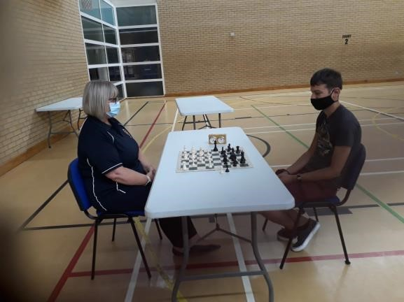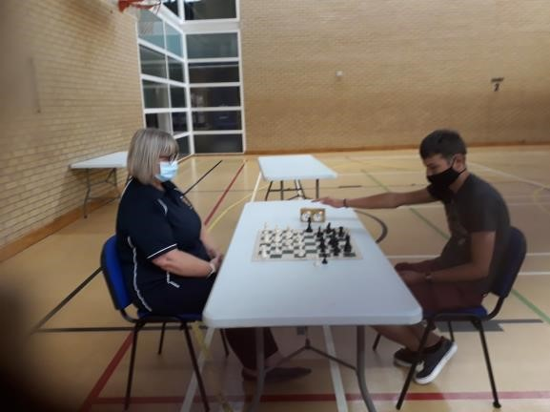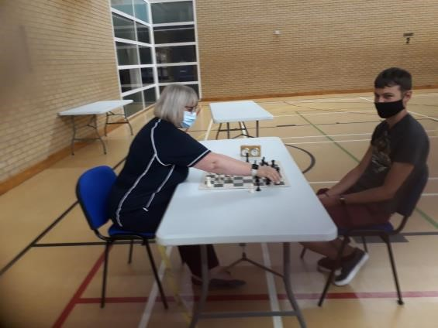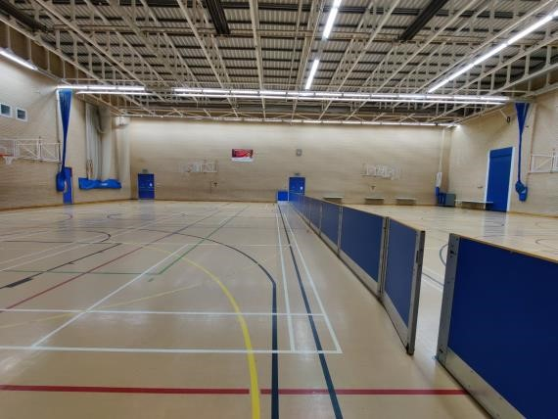

6.2 The dividers in the picture will not be there for the Congress and everything you see is the playing area.

6.3 Players must sit back after making/recording a move. Arbiters will monitor this. Anyone refusing to do so (after two warnings) will default their current game and further repetition be excluded from the tournament.

# IN BETWEEN ROUNDS

7.1 There will be a minimum 90 minute break between the completion of the last game of a morning round and the start of the afternoon playing session.

7.2 Players will not be allowed into the playing hall during the cleaning process.

7.3 There are no catering facilities other than vending machines. Players need to source their own.

7.4 At the time of writing the Congress has not worked out the logistics of where players may go in between rounds. This is an outstanding action which covers –

* A break out area for lunch and
* An analysis room

7.5 There will be no book stall or demonstration boards.

7.6 If and when we have provisioned any/all of the above entrants will be advised. Social distancing rules will be displayed at entry points to these areas, including maximum occupancy. They will be monitored and if after reminder individuals continue to ignore guidelines they (the individual) will be barred from using.

# CHANGES TO CONGRESS

Administration overheads incurred by the Covid measures mean that –

* All sections will have the same start time and time rates. Therefore the Open Section is no longer FIDE rated. Times are 90 minutes with 10 second increments.
* All sections will have the same Entry Fee and Prize structure
* There will be no Foundation Section this year
* Start times for afternoon rounds are now 2:30 p.m. and may be delayed if necessary to complete thorough sanitising of the playing arena.
* There will be no presentation ceremony at the end. Prize winners will be contacted for bank details if required.

# CONCLUSION

The weekend event is ever near and as we approach it Government guidelines change daily. However, we need to proceed in the belief it will happen. So as an immediate follow up to this document being reviewed by the NCA Exec and posted to NTC for approval the following actions will be executed –

* Post all existing entrants, potential entrants and Chess Direct with this document ‘as is’
* Update the Congress entry form with revised schedule, section and prizes
* Complete the floor plan
* On completion of the floor plan produce proposals for accommodating Parents of junior entrants, analysis facilities and a lunch break area
* Continue to monitor and review based on changing circumstance and feedback

Finally Appendix C is a table of actions the Congress is progressing in readiness for the congress and Appendix D shows a history of changes to the document since the first draft.

# APPENDIX A – PLAYING ARENA FLOOR PLAN



# APPENDIX B – MEDICAL CHECKLIST

The following is a list of precautions we should be taking from current NHS employees know to the author. One is a Nurse working in a Covid specific patient ward and one a Radiologist coming into contact with 40 patients a day (not necessarily carrying Covid). The author is awaiting 2 GPs to conclude this (albeit) small sample and provide further independent assurance that the congress is taking appropriate care against contracting/spreading infection.

|  |  |  |
| --- | --- | --- |
| **NUM** | **GUIDELINE** | **DOC REF PARA** |
| 1 | Having experienced wearing PPE of all forms since this unfortunate pandemic started, visors or masks are equally important. | 4.7 |
| 2 | A thermometer gun prior entering the building is essential to monitor the temperature of each participant, as all participants will be departing the venue and coming back all the time. | 4.9 third bullet and 4.14 |
| 3 | Medical gloves, are important as the virus latches on plastic surfaces. As the pieces are coated with a form of plastic, players will need to wear gloves. | 4.8. Gloves are only mandatory for the volunteer team performing cleaning duty in between rounds.  WHO do not recommend use of gloves in the community ([https://www.who.int/emergencies/diseases/novel-coronavirus-2019/question-and-answers-hub/q-a-detail/q-a-on-covid-19-and-masks).](https://www.who.int/emergencies/diseases/novel-coronavirus-2019/question-and-answers-hub/q-a-detail/q-a-on-covid-19-and-masks) |
| 4 | Distancing. One meter circle around the chess table AND the player, will need to be maintained throughout the game and round. | 5. Complies with current Government guidelines |
| 5 | Upon finishing the game, players are to exit the building as there is no need for them to be in the building. | 4.19 third bullet. |
| 6 | Players are to stay around their own table only. | 4.19 second bullet |
| 7 | Air conditioning is important, to avoid humidity and damp surroundings, surrounding that can prove breeding grounds not only for the virus but for other ailments as well. Now one can say I do not care if I get a sore throat as I have not symptoms. Well that might be the case, but there is not guarantee you are an asymptomatic carrier that only needs an ailment to fall ill!! | The playing arena is a sports hall with an extremely high ceiling and good air conditioning |
| 8 | Participants not to be ill 14 days prior to the tournament. By ill, I mean cough, temperature, sneezing, cough etc. We do not know whether the participants are asymptomatic carriers or symptomatic carriers. Therefore, by not following this important point, we are all taking an unnecessary risk. | 2 first bullet |
| 9 | Sanitising gel is needed when gloves come off. | 4.8 |
| 10 | At beginning of tournament and at the end all pieces will need to be sterilised. | 4.10 |
| 11 | Ask people to fill out a short health questionnaire (for example, have you had a temperature or a new cough or loss of smell and/or taste within the last 2 weeks? Have you been in contact with anyone in the last 2 weeks with these symptoms? Have you been in contact with anyone who has been confirmed positive in the last 2 weeks? If yes to any of these turn them away as they would be at risk of spreading the virus.) | 4.9. And leading up to the congress a weekly re-enforced email reminder |
| 12 | Encourage people to use track and trace. | 4.2 and App B Action 8 |

# APPENDIX C – ONGOING ACTIONS

Blue background = complete.

|  |  |  |  |
| --- | --- | --- | --- |
| **Num** | **Action** | **Date Raised** | **Status** |
| 1 | Create document history | 06/08/20 | 13/08/20 - Create action log. Done. Appendix B this doc. Close next issue.  24/09/20 – removed version 0.4 |
| 2 | Verify appropriate Parks/Council personnel have approved congress | 06/08/20 | Posted requesting verification.  13/08/20 – Parks staff assured they manage events and there will be no ‘higher’ intervention. |
| 3 | Confirm compliance with ECF Guidelines and that games will be graded | 06/08/20 | Posted ECF  13/08/20 – There isn’t any obvious reason within <https://www.englishchess.org.uk/wp-content/uploads/2020/08/Tournament-Rules-Aug-2020.pdf> why games won’t be graded. |
| 4 | Update Entry Form | 06/08/20 | 08/09/20 - Done |
| 5 | Produce Exec Summary | 06/08/20 | Done – Version 0.1 |
| 6 | Consider use of social media to update entrants e.g. text, Mailchimp, WhatsApp | 06/08/20 | 24/09/20 - Not enough time, not progressed |
| 7 | Ensure all entrants contactable by mobile phone | 06/08/20 | 12/09/20 – Ongoing. Can only be closed when entries closed |
| 8 | Ensure provision of hotel address for Track and Trace | 06/08/20 | 12/09/20 – Will be done in week leading up to congress |
| 9 | Get volunteers for cleaning duty and possible support entry into playing arena | 06/08/20 | 12/09/20 – Ongoing. 3 to date |
| 10 | Verify Visor/Mask suitability | 06/08/20 | Awaiting feedback from medical professionals  13/08/20 – Parks staff advised masks preferable  12/09/20 – Closed. Visors will only be worn on medical grounds. |
| 11 | Verify wearing of gloves with NHS professionals | 10/10/20 | Awaiting feedback from medical professionals.  12/09/20 – Closed, see Medical Checklist 3 |
| 12 | Where do ‘High Temp’ people wait? Any provision for parents? | 06/08/20 | 13/08/20 – Parks do not mandate this but we will proceed on basis it provides additional reassurance  12/09/20 – High Temp area marked. Still to investigate options pending availability at Parks |
| 13 | Consider producing video showing arrival/entry/playing/exit | 06/08/20 | 13/08/20 – Parks are ok with this  12/09/20 – Planning to do w.c. 13/09/20 |
| 14 | Provide link to document rather than mail out | 06/08/20 | 13/08/20 - Uploaded to NCA website and will be uploaded to Congress website  12/09/20 – Close |
| 15 | Identify and contact parent/s of all U18 entrants to ensure they have read and understood this document | 06/08/20 | 12/09/20 – Will do in week leading up to Congress |
| 16 | Is Covid testing unit at parks over weekend? | 06/08/20 | 13/08/20 – Not sure, things changing so is this action relevant?  12/09/20 – It’s not there anymore. Nearest is Sage building |
| 17 | Purchase Thermometer | 10/08/20 | 12/09/20 – Three ordered |
| 18 | Purchase wipes, handwash, gloves, marker tape | 13/08/20 | 12/09/20 – Purchased gloves, cleaner, bucket, soap, sanitiser, dispensers to supplement what NTC providing. |
| 19 | Who cleans playing arena? | 13/08/20 | 13/08/20 - For duration of congress NCA are responsible for ensuring any touch points are regularly sanitised |
| 20 | Await clarification of 30 person gathering rule | 13/08/20 | 13/08/20 – Posted web extract to NTC for confirmation Congress meets exemptions |