|  |  |  |
| --- | --- | --- |
|  | **ECF Secondary School**  **Rapidplay Chess Tournament**  **Sunday 13th October 2024**  **Eton College, Berks.** |  |

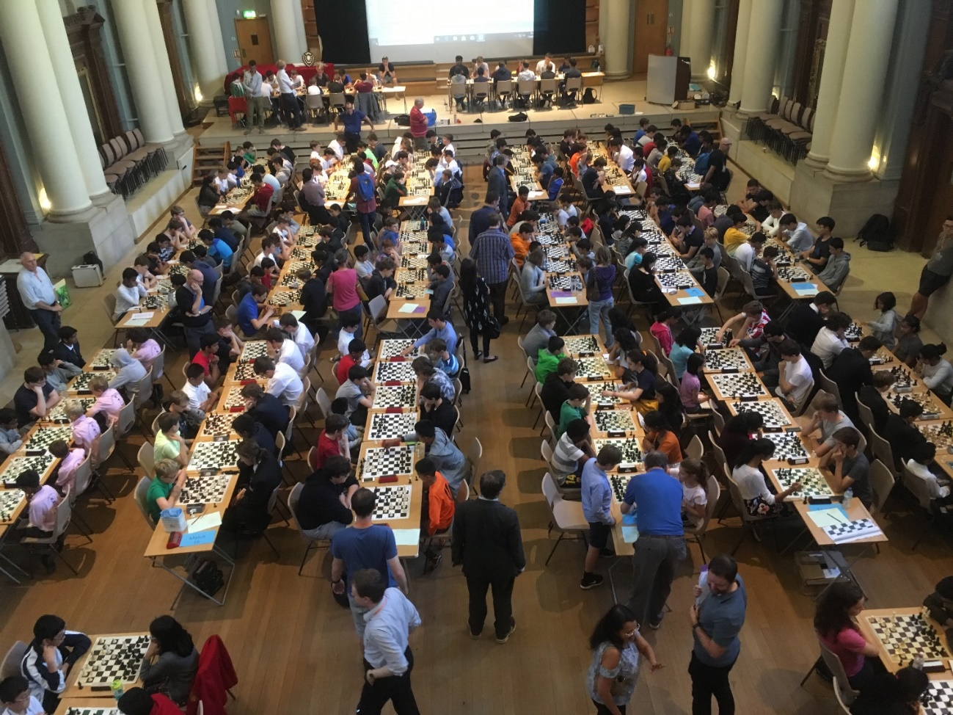

**Venue:** Eton College, Windsor SL4 6DW

**Time**: Registration from 10am, play start 11am, finish about 5pm

**Event Format:** 5 round Swiss rapid play tournament. Digital chess clocks: all moves in 20 minutes + 5 sec/move. All games will be ECF rated.

**Teams**: Teams will consist of 6 players in school years 7 to 13. Schools can enter one or two teams.

**Sections:** This year there will be two sections: Open and Major (team average rating under 1400). Teams will be allocated their section once the October ECF rating list is available.

**Reserves:** Teams can bring a maximum of one reserve who can play instead of a team player in any round. There will not be the provision of games for reserves.

**Cost:** £30.00 per team. Please be prepared to pay by credit/debit card when completing the entry form.

**Player details:** In entering this tournament schools agree to provide the names and dates of birth of all their team players.

**Chess equipment:** It is appreciated when those schools who have suitable chess equipment: sets (with kings over 3 inches high), boards and digital clocks (that can do increments) bring them to this event – see details on the entry form.

Entry form: <https://britchess.wufoo.com/forms/ecf-eton-college-rapidplay-2023/>

More information from Neill Cooper [manager.secondary@englishchess.org.uk](mailto:manager.secondary@englishchess.org.uk)