C10.7.4
BCF Youth Trust
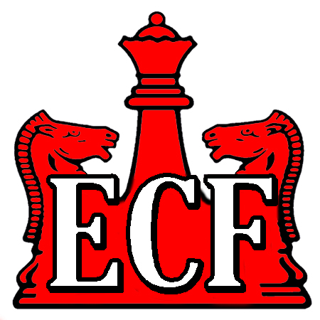

Support to young people playing chess

September 2010

Report to Trustees for Year ending April 2010

Again this year we have been able to focus on supporting youngsters competing in prestigious international events which are not financed in the normal budget of the English Chess Federation’s Director of Junior Chess & Education. The element of our support to ‘grass roots’ chess has been more than adequately met by the work I continue to do via the Certificate of Excellence Scheme. T

Notes:

- European Union Youth Championships, Mureck in Austria – support to provide professional coaching to the team. This event is proving to be a most valuable experience for our younger players as many have progressed to representing England at the European Youth Championships and the World Youth Championships.

- Cappelle Open International Tournament – this tournament ranks as one of world’s largest open events and, with over 200 titled players competing, provides an opportunity for our juniors to improve their international ratings and to achieve title norms. We funded the cost of providing professional coaching for the England team.

- Certificate of Excellence – grant of £1,500 towards the purchase of support material and ‘goodies’ such as pens, badges, score pads and furry mascots which are sent out with each examination pack.

- Grant of £500 to David Howell to support his participation in the World U21 Championships.

Yours sincerely

P R Turner

Peter Turner
ECF Honorary Life Vice-President
Chairman to BCF Youth Chess Trust
CC. Trustees
CC ECF Office
CC Charity Commission

